Social Media Tool Kit

Post 1: Before the Collection
The link in the post leads to a video. Be sure to copy the whole link and the video will automatically be linked on Facebook and Twitter!

Facebook/Twitter:
Check out life at the poverty line. Support the Catholic Campaign for Human Development collection at Mass. #PowerOfCCHD #1church1mission https://goo.gl/MFO7fn

Post 2: Before the Collection
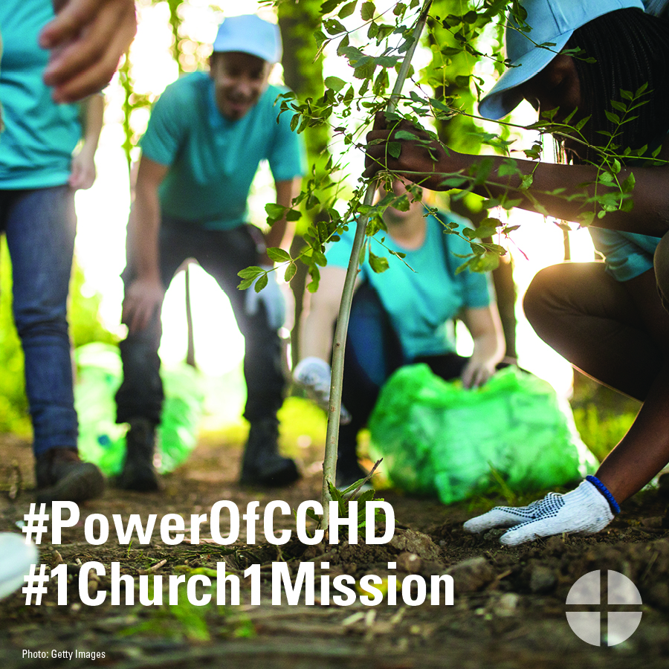

Facebook/Instagram/Twitter:
Did you know that more than 46 million Americans live below the poverty line? You can help by supporting the collection for the Catholic Campaign for Human Development at Mass! #PowerOfCCHD #1church1mission www.povertyusa.org

Post 3: Before the Collection
The link in the posts leads to a video. Be sure to copy the whole link and the video will automatically be linked on Facebook!

Facebook/Twitter:
Have three minutes? Use them to learn about how the USCCB addresses poverty in this interview with CCHD director Ralph McCloud! #PowerOfCCHD #1church1mission https://goo.gl/UMoEIz

Post 4: Before the Collection
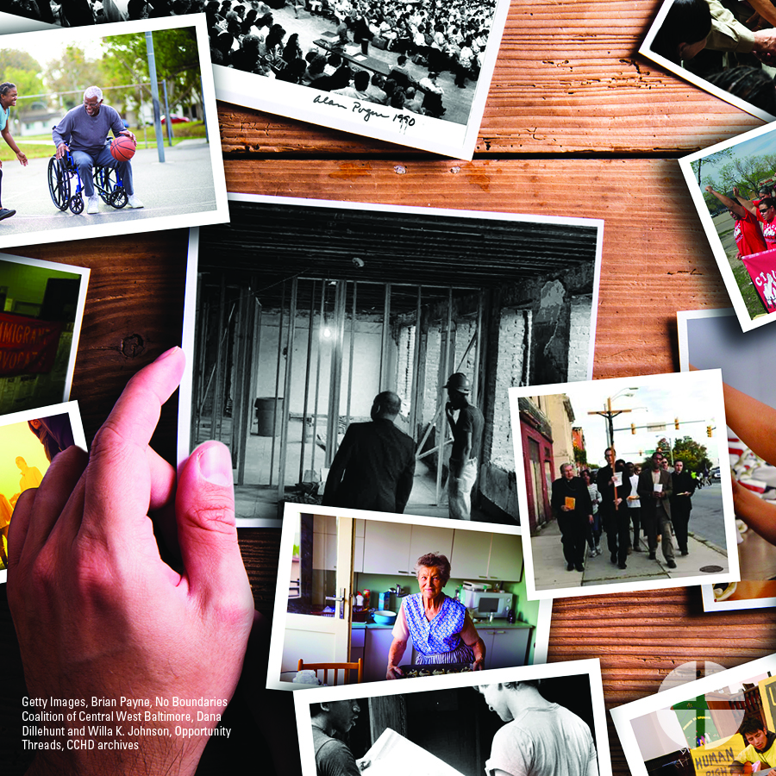
Facebook/Instagram/Twitter:
The collection for the Catholic Campaign for Human Development helps people working to end poverty in the United States. Support the collection at Mass! #PowerOfCCHD #1church1mission http://goo.gl/I6FqfW

Post 5: Before the Collection
The link in the posts leads to the newsletter information page. Be sure to copy the whole link and it will automatically be linked on Facebook and Twitter!

Facebook/Twitter:
Want to stay up to date on how the Catholic Campaign for Human Development is working to break the cycle of poverty? Sign up for the quarterly newsletter, “Helping People Help Themselves.” #PowerOfCCHD #1church1mission http://goo.gl/iktA5H

Post 6: Week of the Collection
The link in the posts leads to a video. Be sure to copy the whole link and the video will automatically be linked on Facebook and Twitter!

Facebook/Twitter:
Who receives funding from the collection for the Catholic Campaign for Human Development? Watch our “Meet Mary” video and see how your donations break the cycle of poverty. #PowerOfCCHD #1church1mission https://goo.gl/OouOcF

Post 7: Week of the Collection
Facebook/Instagram/Twitter:
This weekend, we take up the collection for the Catholic Campaign for Human Development! Join the effort to break the cycle of poverty in the United States. #PowerOfCCHD #1church1mission http://goo.gl/I6FqfW

Post 8: Week of the Collection
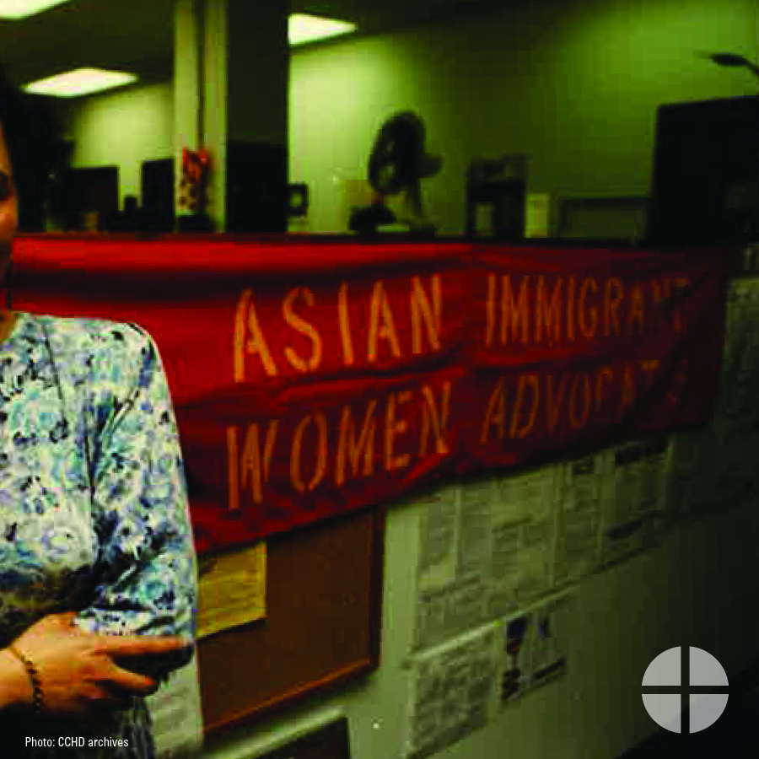
Facebook/Instagram/Twitter:
This weekend, our special collection supports the Catholic Campaign for Human Development. 25 percent of funds we collect will stay here in the diocese for antipoverty projects. Please be generous! #PowerofCCHD #1church1mission http://goo.gl/I6FqfW

Post 9: Day of the Collection
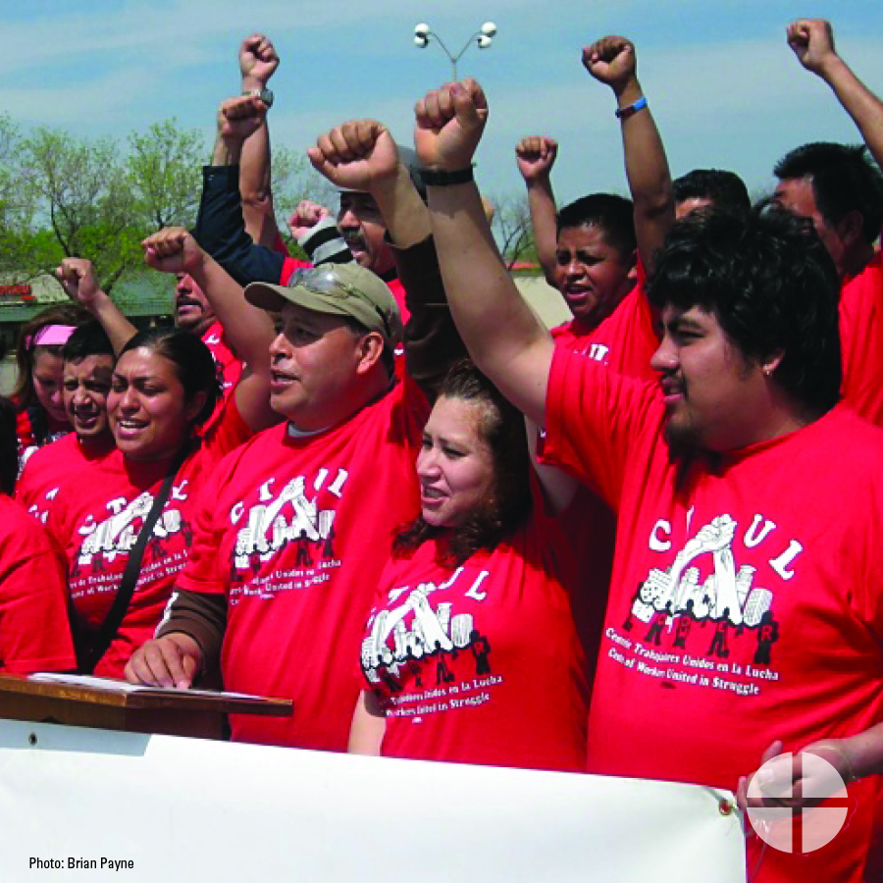
Facebook/Instagram/Twitter:
Today, our special collection supports the Catholic Campaign for Human Development! Please be generous and help end the cycle of poverty in the United States. #PowerofCCHD #1church1mission www.povertyusa.org

