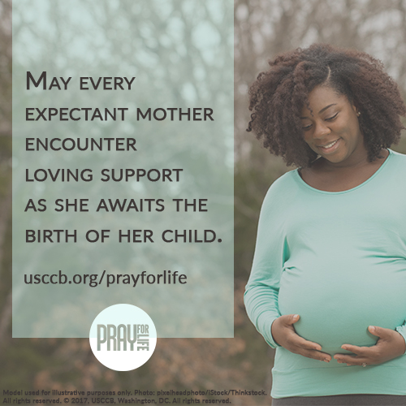

**\*For the hyperlinked materials on this page,**

**visit the 2017 Pray for Life Archive, accessible at** [**www.usccb.org/prayforlife**](http://www.usccb.org/prayforlife)**,**

Did you know?

The bishops’ annual pro-life digital pilgrimage, **9 Days for Life**, takes place from Thursday, January 18 – Friday, January 26. Join and check out the other ways you can participate at [www.9daysforlife.com](http://www.9daysforlife.com).

There are also [many resources to help leaders](http://www.usccb.org/about/pro-life-activities/january-roe-events/9-days-for-life-resources-for-leaders.cfm) integrate 9 Days for Life into their regular programming or to plan special events as part of local participation.

Prayers

*Our Father, 3 Hail Marys, Glory Be*

Reflection

For an expectant mother whose pregnancy is marked by challenging circumstances, the time before the birth of her child can be full of uncertainty and fear. In this period of anticipation, the future can seem threatening, and even a woman who identifies as being pro-life might consider abortion. Without a community of support from friends and family, a new mother’s pregnancy can be more painful than joyous.

As Catholics, we have a duty to respond with life-affirming love for both an expectant mother and her child. If someone shared with you she was pregnant and hadn’t ruled out abortion, would you know how to respond?

Read [What To Do When A Friend Is Considering Abortion](http://www.usccb.org/about/pro-life-activities/respect-life-program/2017/what-to-do-when-a-friend-is-considering-abortion.cfm) to learn the four steps of the L.O.V.E. ApproachTM*: *Listen and Learn*, *Open Options*, *Vision and Value*, and *Extend and Empower*.

*The L.O.V.E. Approach™ is trademarked by Heartbeat International, Inc. and may not be adapted or modified. The L.O.V.E. Approach™ is used in "What to Do When a Friend Is Considering Abortion" with permission from Heartbeat International, Inc.

One Step Further

Read “[10 Ways to Support Her When She’s Unexpectedly Expecting](http://www.usccb.org/about/pro-life-activities/respect-life-program/2015/10-ways-to-support-her-when-shes-unexpectedly-expecting.cfm),” and share it on social media with your favorite suggestion.

* Bulletin Insert: [English](http://www.usccb.org/about/pro-life-activities/respect-life-program/2015/upload/10-ways-to-support-her-when-she-is-unexpectedly-expecting-eng-2.pdf) / [Spanish](http://www.usccb.org/about/pro-life-activities/respect-life-program/2015/upload/10-ways-to-support-her-when-she-is-unexpectedly-expecting-esp.pdf)
* Order: [English](http://store.usccb.org/10-Ways-to-Support-Her-When-She-s-Unexpectedly-Exp-p/c1541.htm) / [Spanish](http://store.usccb.org/10-maneras-de-apoyarla-cuando-esta-esperando-sin-h-p/c1551.htm)

Acts of Reparation (choose one)

* Donate needed items to a pregnancy care center, or volunteer an hour of your time at one. Find a center near you at [www.heartbeatinternational.org/worldwide-directory](http://www.heartbeatinternational.org/worldwide-directory).
* Ask Our Lady of Guadalupe for her intercession using [this short prayer](http://www.usccb.org/prayer-and-worship/prayers-and-devotions/prayers/a-prayer-to-our-lady-of-guadalupe.cfm). Consider praying it every day for the next week.
* Reach out to a friend or family member who is pregnant, and ask how you can support them, or offer specific help, like making a meal or running errands.

Copyright © 2017, United States Conference of Catholic Bishops, Washington, DC. All rights reserved.

www.usccb.org/prayforlife