Table of Contents
Homily Helps: Q & A……………………………………2
Readings for Respect Life Sunday………..2-3
Homily Notes…………………………………………………4
2018-2019 Respect Life Reflection………...5
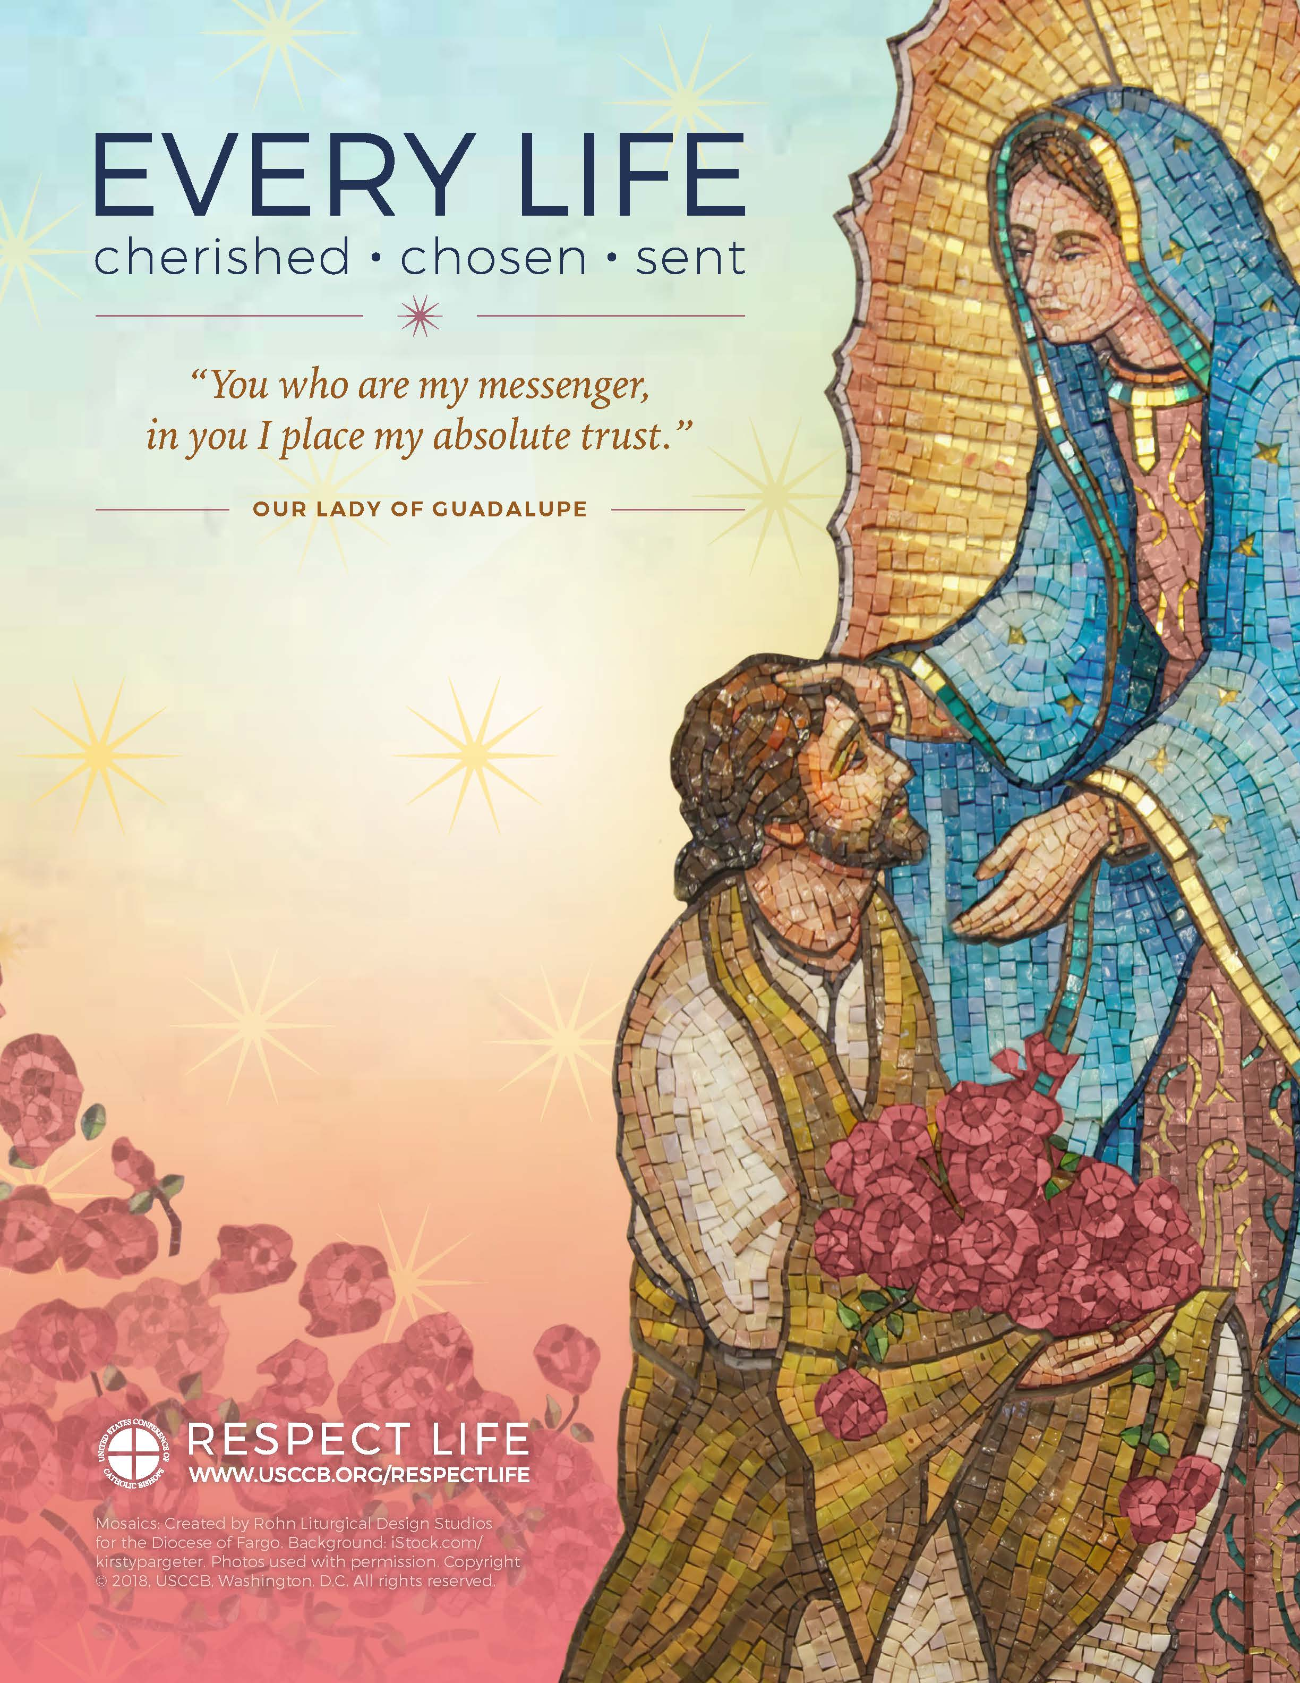  Homily Helps for  Respect Life Month  Every Life: Cherished, Chosen, Sent | The Respect Life Program, sponsored by the United States Conference of Catholic Bishops, started in 1972 and begins anew each October—the month set aside by the U.S. bishops as “Respect Life Month.”  It’s a year-round, nationwide effort by leaders like you to help Catholics understand, value, and become engaged with building a culture that cherishes every human life.  The U.S. bishops produce printed and digital tools to help leaders throughout the Church integrate the Gospel of Life into their work or ministry.  Take a look at the 2018-19 Respect Life Clergy Kit for free resources and ideas for sharing the life-giving message, “Every Life: Cherished, Chosen, Sent”!

Suggested Observance:
Respect Life Sunday, October 7, 2018
Twenty-seventh Sunday in Ordinary Time
Homily Helps: Q & A
What are these?
The following readings and suggested notes are provided to assist with sharing the message of missionary discipleship in relation to God’s gift of human life. The notes unpack the 2018-2019 Respect Life theme, “Every Life: Cherished, Chosen, Sent” and integrate the readings of Sunday, October 7, 2018 (Respect Life Sunday).
Who are they for?
Although especially developed to assist priests and deacons with sharing the Gospel of Life in their homilies, these notes can also be used by other Catholic leaders.
For example, during Respect Life Month, high school teachers could incorporate one or more points into classes on Scripture, morality, Catholic Social Teaching, etc. Youth ministers could use the notes to develop a short reflection for a Respect Life event marking the annual Day of Prayer for the Legal Protection of Unborn in January. Anyone is welcome to use them to help build a culture of life!
How do I use them?
The notes are meant to be adapted according to your needs. You are welcome to pull individual points, use the entire framework, or any other variation that is useful to you.
When do I use them?
The notes are suggested for use on October 7, 2018 (Respect Life Sunday), but you are welcome to use them at any time—during Respect Life Month (October) or otherwise.
Anything else?
Yes! Take a look at the 2018-19 Respect Life Clergy Kit for other resources and ideas for sharing the life-giving message of “Every Life: Cherished, Chosen, Sent”! (Customized toolkits for other Catholic leaders are also available.)
Readings for Sunday, October 7, 2017
Readings
First Reading: Gn 2:18-24
Responsorial Psalm: Ps 128:1-2, 3, 4-5, 6
Second Reading: Heb 2:9-11
Gospel Acclamation: 1 Jn 4:12
Gospel: Mk 10:2-16
First Reading: Gn 2:18-24
The LORD God said: “It is not good for the man to be alone.
I will make a suitable partner for him.”
So the LORD God formed out of the ground
various wild animals and various birds of the air,
and he brought them to the man to see what he would call them;
whatever the man called each of them would be its name.
The man gave names to all the cattle,
all the birds of the air, and all wild animals;
but none proved to be the suitable partner for the man.
So the LORD God cast a deep sleep on the man,
and while he was asleep,
he took out one of his ribs and closed up its place with flesh.
The LORD God then built up into a woman the rib
that he had taken from the man.
When he brought her to the man, the man said:
“This one, at last, is bone of my bones
and flesh of my flesh;
this one shall be called ‘woman,’
for out of ‘her man’ this one has been taken.”
That is why a man leaves his father and mother
and clings to his wife,
and the two of them become one flesh.
Responsorial Psalm: Ps 128:1-2, 3, 4-5, 6
℟. May the Lord bless us all the days of our lives.
Blessed are you who fear the LORD,
who walk in his ways!
For you shall eat the fruit of your handiwork;
blessed shall you be, and favored.
Your wife shall be like a fruitful vine
in the recesses of your home;
your children like olive plants
around your table.
Behold, thus is the man blessed
who fears the LORD.
The LORD bless you from Zion:
may you see the prosperity of Jerusalem
all the days of your life.
May you see your children's children.
Peace be upon Israel!
Second Reading: Heb 2:9-11
Brothers and sisters:
He “for a little while” was made “lower than the angels,”
that by the grace of God he might taste death for everyone.
For it was fitting that he,
for whom and through whom all things exist,
in bringing many children to glory,
should make the leader to their salvation perfect through suffering.
He who consecrates and those who are being consecrated
all have one origin.
Therefore, he is not ashamed to call them “brothers.”
Gospel Acclamation: 1 Jn 4:12
If we love one another, God remains in us
and his love is brought to perfection in us.
Gospel: Mk 10:2-16
The Pharisees approached Jesus and asked,
“Is it lawful for a husband to divorce his wife?”
They were testing him. He said to them in reply, “What did Moses command you?”
They replied,
“Moses permitted a husband to write a bill of divorce and dismiss her.”
But Jesus told them,
“Because of the hardness of your hearts
he wrote you this commandment. But from the beginning of creation,
God made them male and female. For this reason a man shall leave his father and mother and be joined to his wife, and the two shall become one flesh.
So they are no longer two but one flesh. Therefore what God has joined together, no human being must separate.”
In the house the disciples again questioned Jesus about this. He said to them,
“Whoever divorces his wife and marries another commits adultery against her; and if she divorces her husband and marries another, she commits adultery.”
And people were bringing children to him that he might touch them, but the disciples rebuked them. When Jesus saw this he became indignant and said to them,
“Let the children come to me; do not prevent them, for the kingdom of God belongs to such as these. Amen, I say to you, whoever does not accept the kingdom of God like a child will not enter it.”
Then he embraced them and blessed them, placing his hands on them.
Homily Notes

Respect Life Sunday | October 7, 2018

Twenty-seventh Sunday in Ordinary Time
Suggestions for unpacking the 2018-2019 Respect Life theme (“Every Life: Cherished, Chosen, Sent”) using the readings of the day.
Our Lady of Guadalupe
Briefly share the story of Our Lady of Guadalupe and St. Juan Diego, summarized in the 2018-2019 Respect Life Reflection.
Created for Relationship
Every person is made in God’s image and likeness (First Reading), and is loved by Him and called to eternal union with Him. We are also created to be in communion with, and depend upon, one another. Jesus consecrates us and calls us his “brothers” (Second Reading).
Love One Another
We are all called to walk in God’s ways (Responsorial Psalm) and treat each other according to the truth of His immense love for every person (Gospel Acclamation). Like St. Juan Diego, we are personally entrusted with specific ways to love God and one another. If we have aging parents, do we take the time to consistently show our love through visits, phone calls, and notes? If we know expectant mothers or parents with infants, do we provide support that helps them welcome their children (Gospel Reading) and continues to serve their needs, even months after the baby is born?
It’s Who We Are
We are cherished, chosen, and sent by God to love one another as He loves us. In doing so, we help build a culture that cherishes all human life. Building a culture of life is simply part of who we are as Christians, as followers of Christ.

2018-2019 Respect Life Reflection
In 1531, when the indigenous peoples of Mexico were subjugated and the practice of human sacrifice was still a recent memory, the Mother of God appeared to St. Juan Diego as a pregnant native woman, now known as Our Lady of Guadalupe.
She sent him with miraculous flowers in his cloak to tell the bishop to build a church where people could receive her Son and her loving, tender care. When St. Juan Diego opened the cloak before the bishop, an image of Our Lady was revealed that remains to this day. The chapel was quickly built, millions embraced Christianity, and the Church increased its protection of the indigenous peoples.
You who are my messenger, in you I place my absolute trust.
– Our Lady of Guadalupe
By embracing the mission entrusted to him, St. Juan Diego helped bring Christ’s transforming love to cultures gripped by oppression and death.
Today, we again see the dignity of human life disregarded. Unborn children are destroyed through abortion, and ill people are encouraged and assisted to take their own lives. How do we respond?
The essence of our identity is that we are created in God’s image and likeness and loved by Him. Nothing can diminish the priceless worth of any human life. Every person is cherished.
God creates every person for eternal union with Himself and continually invites us to embrace a loving relationship with Him. Every person is chosen.
We are called to be messengers of God’s love, treating one another as cherished and chosen by Him. In doing so, we help build a culture that respects all human life. Every person is sent.
Like St. Juan Diego, let us embrace our daily mission to help others encounter God’s transforming, life-giving love.

