Sample Note to Parishes
Advocacy for the Born-Alive Abortion Survivors Protection Act
[Date]
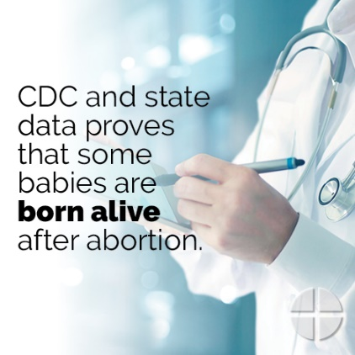
Dear Respect Life leader:
I’m writing today regarding an effort for which I ask your prayers and support.
Sometimes, babies survive an attempted abortion and are born alive. According to the Centers for Disease Control and some states, it could be potentially hundreds of babies each year.
But rather than receiving the same degree of care as any other newborn baby, some of these babies are then left alone to die, or even killed. Existing law is insufficient to protect babies like these from infanticide.
So, the Born-Alive Abortion Survivors Protection Act (H.R. 962) was introduced in Congress. But abortion advocates in the U.S. House of Representatives won’t allow a vote on the bill. A “discharge petition” has been filed, which means that if enough U.S. representatives sign their names to the petition, it would override this obstruction and enable a vote.
It will take work to get enough signatures, but it IS possible. That’s where our [arch/diocese] comes in.
Our U.S. [representative/s has/have] been identified as possibly being open to signing this petition if [he/she/they hear/hears] from enough constituents. [Arch/bishop Name] is asking us to rally our people in support of babies who survive abortion.
One way we are responding is to target the [weekend/s of …] to focus on this issue. The USCCB is providing resources to assist our efforts. Please take a moment to review the list on the next page and consider how your parish can participate.
Another crucial way we are responding is to ask that as many people as possible visit Representative [Name] [Date] when he/she is in the district office during the congressional recess. Talking points and a simple lobbying guide are among the resources provided by the USCCB. Please consider how you can best encourage your fellow parishioners to take advantage of this vital opportunity.
The following resources are available online at www.bit.ly/born-alive-resources:
- www.babiesbornalive.com - website where people can send a message to our U.S. [representative/s] and access resources
- Texting option to contact our U.S. representative: Text ALIVE to 50457. (Standard messaging & data rates apply.)
- Bulletin announcements
- Graphics (There are two virtually identical sets of graphics, with slight differences for different uses. Use the graphics displaying www.babiesbornalive.com on social media and the graphics with the text-in keyword ALIVE for printed materials like parish bulletins.)
- Sample social media posts
- Fact sheet
- 15 and 30-second audio PSAs
- “How to” guide for parish advocacy event
- Tips for writing letters to local newspapers
- Lobbying guide
- Talking points
- Video
Please keep this effort in your continued prayers, and thank you for your dedication to protecting these little ones’ lives!
Sincerely,

