Sample Bulletin Announcements
Born Alive Abortion Survivors Protection Act
For this and other resources,
Visit www.bit.ly/born-alive-resources.

Graphics
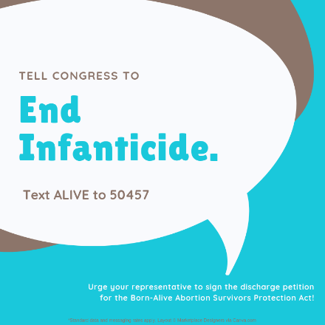
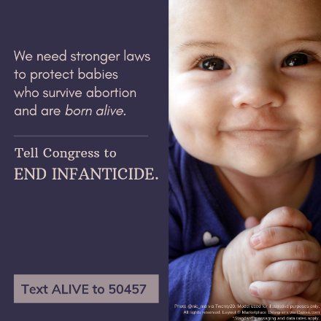
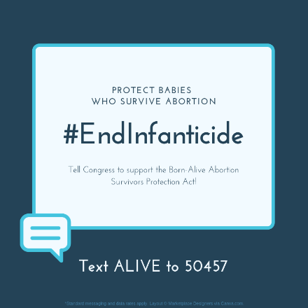
If space permits, include a graphic with your bulletin or newsletter announcement. These and others are available from the website at the top of the page. These and others are available here. (Be sure to use the versions with the text-in keyword, rather than the website.)

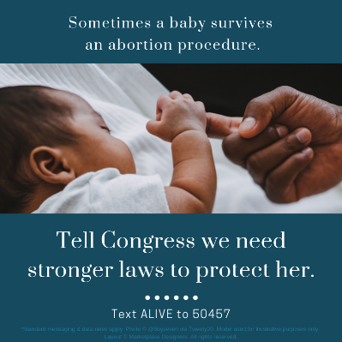
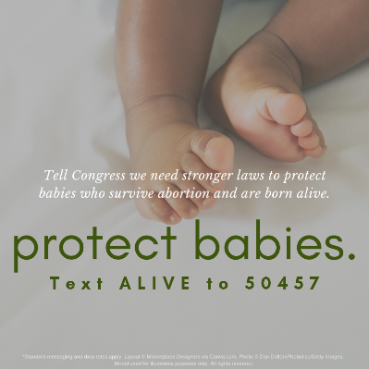
Announcements
Adapt the highlighted text to reflect whether you have one or more U.S. representatives and who they are.
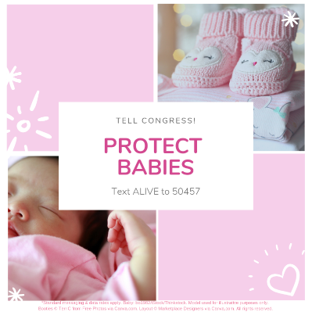
Option A
Tell Congress “Enough”
Our U.S. Representative(s), [Name(s)], need(s) to hear from us. Sometimes, babies are born alive during an attempted abortion. Some of these babies are then left alone to die, or even killed. We need stronger laws to protect babies like these from infanticide. Please contact Representative [Name], and ask him / her to sign the discharge petition for the Born Alive Abortion Survivors Protection Act. Text ALIVE to 50457 or visit www.babiesbornalive.com to send your message in under two minutes!
Option B
2 Minutes to #EndInfanticide
Our U.S. Representative, [Name], needs to hear from us. Sometimes, babies are born alive during an attempted abortion. Some of these babies are then left to die alone, or even killed. Please ask Representative [Name] to sign the discharge petition for the Born Alive Abortion Survivors Protection Act. Text ALIVE to 50457 or visit www.babiesbornalive.com.
Option C
Protect Babies Born Alive
Sometimes babies are born alive during an attempted abortion and are left alone to die, or even killed. Please urge U.S. Representative [Name] to help stop infanticide. Text ALIVE to 50457 or visit www.babiesbornalive.com.
Option D
2 Minutes to Protect Babies
Urge U.S. Representative [Name] to help stop infanticide. Text ALIVE to 50457 or visit www.babiesbornalive.com.

