Word of Life: March 2018
Recommended dates are provided, but you are welcome to use these materials at any time!
Featured this Month…
Conscience Protection
Health care providers and trainees, churches, and others are being forced to participate in abortions or provide coverage for it in their health care plans. Federal conscience laws prohibit such coercion, but these laws continue to be violated—mostly because they don’t provide victims with the ability to defend their rights in court.
In March, Congress will likely decide whether to address the problems in current law by enacting the Conscience Protection Act. No one should be forced to participate in abortion. Members of Congress need to hear from their constituents. Please help us spread the word!

Please consider using one or more on Sunday, March 4 and/or Sunday, March 11.
- Bulletin Graphic(s) on Page 4
- Bulletin Announcement(s)
Option A (95 words):
Congress needs to hear from us! Health care providers and trainees, churches, and others are being forced to participate in abortion or provide coverage for it in their health care plans. Federal conscience laws prohibit such coercion, but these laws continue to be violated—mostly because they don’t provide victims with the ability to defend their rights in court.
Within a couple weeks, Congress will likely decide whether to improve enforcement of these laws by enacting the Conscience Protection Act. No one should be forced to participate in abortion. Tell your representatives TODAY at humanlifeaction.org!
Option B (56 words):
Health care providers, churches, and others are being forced to participate in abortion or provide coverage for it in their health care plans, in violation of federal conscience laws. Within a couple weeks, Congress will likely decide whether to improve enforcement of these laws by enacting the Conscience Protection Act. Voice your support TODAY at humanlifeaction.org!
Option C (40 words):
Health care providers, churches, and others are being forced to participate in abortion or provide health care coverage for it. Urge Congress to stop this coercion by passing the Conscience Protection Act. Send your representatives a message TODAY at www.humanlifeaction.org!
Option D (16 words): Urge Congress to pass the Conscience Protection Act. Send your representatives a message TODAY at humanlifeaction.org!
Word of Life – March 2018
Intercessions for Life
March 4th Third Sunday of Lent
Through their work, may lawmakers
protect the conscience rights of
those who stand up for life;
We pray to the Lord:

March 11th Fourth Sunday of Lent
For health care providers
refusing to participate in abortion:
May they be protected from
coercion and discrimination;
We pray to the Lord:

March 18th Fifth Sunday of Lent
May God create clean hearts in us,
that we may see and treat others
as His beautiful creations;
We pray to the Lord:

March 25th Palm Sunday of the Lord’s Passion
May Christ give us the grace
of loving self-sacrifice,
as we cherish every person’s life;
We pray to the Lord:

Word of Life – March 2018

Bulletin Quotes

March 4th  “O God our Creator… give us courage in making our voices heard on behalf of the rights of your Church and the freedom of conscience of all people of faith.”  USCCB, “Prayer for the Protection of Religious Liberty” www.bit.ly/ReligiousLibertyPrayer | 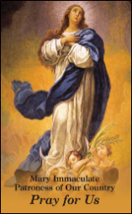  Order | Download
March 11th  “When I voiced my objections to do abortion-related services, I was terminated. It’s against my conscience. I became a nurse to protect lives, not to take lives.” – Sandra Mendoza, L.P.N.  Take Action: www.humanlifeaction.org  Video: www.bit.ly/StandWithSandra | 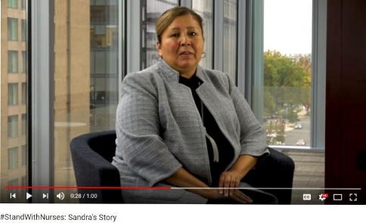  View Online
March 18th  “When God created each of us, He did so with precision and purpose… let us treat each person as the masterpiece that he or she is.”  USCCB Secretariat of Pro-Life Activities  Respect Life Flyer: “Each of Us is a Masterpiece of God’s Creation” www.bit.ly/GodsMasterpieces | 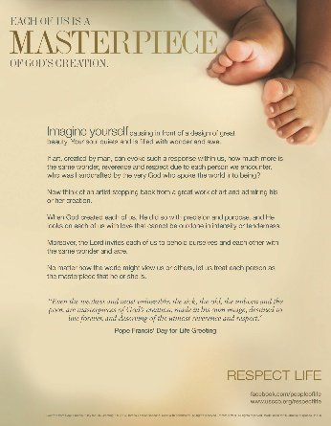  Download
March 25th  “Respect for the human person proceeds by way of respect for the principle that ‘everyone should look upon his neighbor (without any exception) as “another self,” above all bearing in mind his life and the means necessary for living it with dignity.’”  Catechism of the Catholic Church, 1931. www.bit.ly/CCC1931 |  | 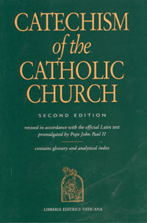  Order | View Online

Word of Life - March 2018

Bulletin Art
You are welcome to use these and other downloadable images from the online Respect Life image gallery, provided they are not altered in any way, other than the size. Thank you!

Sunday, March 4th, 2018

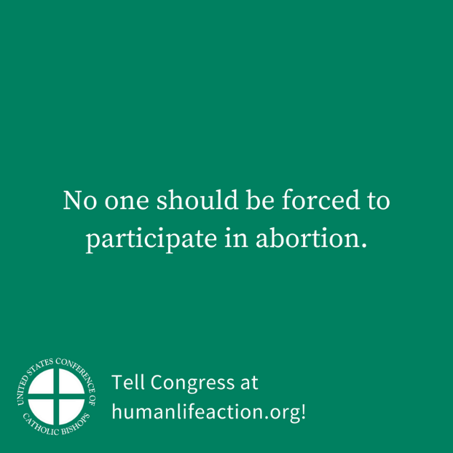
Download Image: English | Spanish

Sunday, March 11th, 2018

Download Image: English | Spanish

