Word of Life: December 2018
Recommended dates are provided, but you are welcome to use these materials at any time!
Intercessions for Life
December 2nd  For all unborn children:  That their families will prepare  to welcome them with joy  and awareness of the many gifts  children bring into the world;  We pray to the Lord: | First Sunday of Advent
December 8th  May our Blessed Mother help us trust in God,  that we may peacefully care for those  whose lives are entrusted to us;  We pray to the Lord: | Solemnity of the Immaculate Conception  of the Blessed Virgin Mary
December 9th  For expectant mothers:  That the Lord will provide for all of their needs  and prepare them to welcome their children with joy;  We pray to the Lord: | Second Sunday of Advent
December 16th  For unborn children:  That by the intercession of Our Lady of Guadalupe,  their human dignity will be recognized, respected, and protected by all from the moment of conception;  We pray to the Lord: | Third Sunday of Advent
December 23rd  For married couples who long  to welcome a child into their family:  May the coming of the Christ Child  bring hope and peace;  We pray to the Lord: | Fourth Sunday of Advent
December 25th  For all Christians:  That the wondrous birth of Our Lord Jesus Christ  will awaken our hearts to the priceless gift of every child;  We pray to the Lord: | The Nativity of the Lord—Christmas
December 30th  For all families:  That the courage to be examples  of love and holiness in our world  will guide parents and children throughout each day;  We pray to the Lord: | Feast of the Holy Family  of Jesus, Mary and Joseph

Word of Life – December 2018

Bulletin Quotes
December 2nd  “Every life is a good and perfect gift. Many know this on an intellectual level, but those who love someone with a disability see it in their loved one's face in a particular way. Our love for our children has nothing to do with their abilities. We love them simply because of who they are, and understanding this teaches us how to truly love everyone.”  USCCB Secretariat of Pro-Life Activities  “A Perfect Gift,” www.usccb.org/perfect-gift | 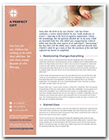  Order | Download
December 9th  “‘Perhaps one of your friends has become pregnant unexpectedly. As someone who has been there, I encourage you to support your friend in her new journey of being a mother. Not sure how to help or what to say?’ Learn ten tips at www.usccb.org/support-her.”  “10 Ways to Support Her When She’s Unexpectedly Expecting”  USCCB Secretariat of Pro-Life Activities | 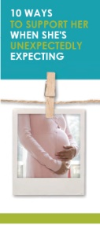  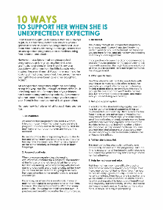  Order | Download
December 16th  “In 1531, when the indigenous peoples of Mexico were subjugated and the practice of human sacrifice was still a recent memory, the Mother of God appeared to St. Juan Diego as a pregnant native woman, now known as Our Lady of Guadalupe.  She sent him with miraculous flowers in his cloak to tell the bishop to build a church where people could receive her Son and her loving, tender care. When St. Juan Diego opened the cloak before the bishop, an image of Our Lady was revealed that remains to this day. The chapel was quickly built, millions embraced Christianity, and the Church increased its protection of the indigenous peoples.”  USCCB Secretariat of Pro-Life Activities  2018-19 Respect Life Reflection, www.usccb.org/respect-life-reflection | 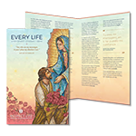  Order | Download
December 23rd
“To couples who cannot have children of their own, you are no less loved by God; your love for each other is complete and fruitful when it is open to others.”

Pope Saint John Paul II, February 13, 1982 Homily. © 1982 Libreria Editrice
Vaticana. Used with permission. www.goo.gl/jLDs4e

December 30th  “Blessed Joseph,  You took Mary and Jesus into your  home. You followed the prescripts of the Law,  presented Jesus in the Temple,  taught him skills at the plane and the lathe, and,  daily, you shared traditions which were built on the  covenants he came to fulfill.  Hear the prayers of the siblings, grandparents,  aunts, uncles, and entire families of children who  have been adopted.  May they be a source of loving welcome and a  fount of faith.  Through Christ our Lord.  St. Joseph, descendant of David, pray for us.”  USCCB Secretariat of Pro-Life Activities  “Novena to St Joseph for Those on the Path of Adoption.” | 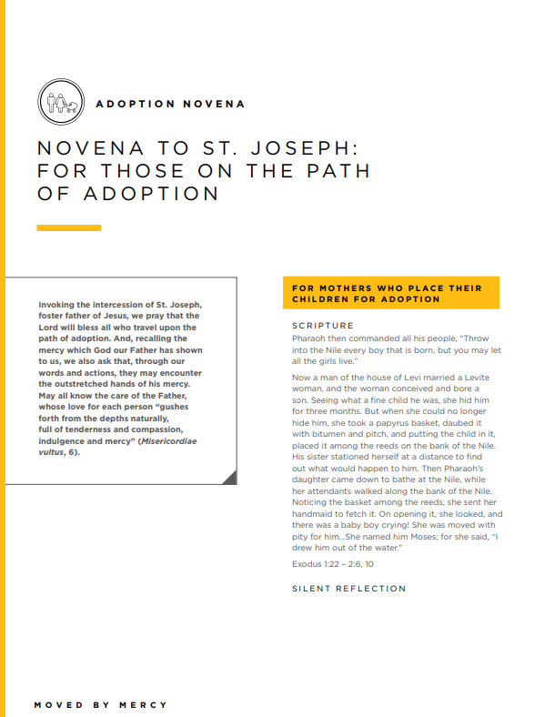

Word of Life - December 2018

Bulletin Art
You are welcome to use these and other downloadable images from the online Respect Life image gallery, provided they are not altered in any way, other than the size. Thank you!
Sunday, December 2nd, 2018
Featuring “A Perfect Gift”
- Bulletin Insert: Color | Grayscale
- Download Image: English | Spanish

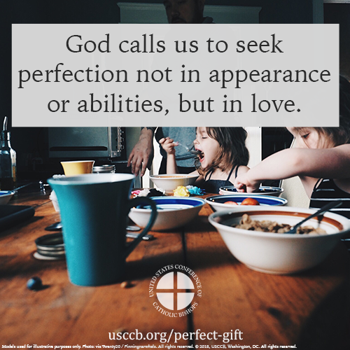
Sunday, December 9th, 2018
Featuring “10 Ways to Support Her When She’s Unexpectedly Expecting”
- Bulletin Insert: Color | Grayscale
- Download Image: English | Spanish
