Word of Life: May 2019
Recommended dates are provided, but you are welcome to use these materials at any time!

Featured this Month…

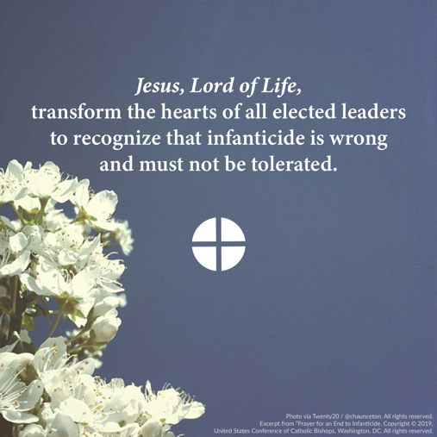
Prayer for an End to Infanticide
The U.S. Senate recently failed to pass the Born-Alive Abortion Survivors Protection Act, but that is not the end of the story. This bill, rooted in our most fundamental human values, is worth fighting for. It would prohibit infanticide by ensuring that a child born alive following an attempted abortion would receive the same degree of care to preserve her or his life and health as would be given to any other child born alive at the same gestational age.
Please join us in praying the Prayer for an End to Infanticide.
*Note: You can learn how your senators voted online.
Mother’s Day: Sunday, May 12th
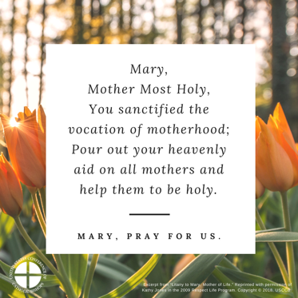
Mother’s Day is a wonderful opportunity to highlight several pro-life issues. For example, you may consider inviting your parish priest to offer a Blessing of the Child in the Womb in support of expectant mothers and the babies they are carrying.
As we pray in thanksgiving for the gift of all mothers, we also specifically lift up mothers experiencing a crisis pregnancy, that they may find support and encouragement and choose life for their child.
It is also important to remember that Mother’s Day can be a difficult holiday for many people, including: couples struggling with infertility; parents who have lost a child; those who have lost their own mothers; couples longing to welcome a child through adoption; and women who have been wounded by participation in abortion.
A number of resources are available to help address these circumstances:
- Seven Considerations While Navigating Infertility
- Bridges of Mercy for Healing After Abortion
- An Adoption Love Story
- 10 Ways to Support Her When She’s Unexpectedly Expecting
- Supporting Families Who Receive a Prenatal Diagnosis
- Accompanying Expectant Mothers Considering Adoption

Word of Life – May 2019
Intercessions for Life
May 5th  For an end to infanticide:  That the laws of our nation may reflect the law of God,  and protect the dignity of every human life;  We pray to the Lord: | Third Sunday of Easter
May 12th  For those struggling with infertility:  May their hearts rest in the Good Shepherd,  whose faithfulness endures to all generations;  We pray to the Lord: | Fourth Sunday of Easter
May 19th  For those who are dying:  That they be treated with respect, care, and Christian love  that reflects the gift of their lives;  We pray to the Lord: | Fifth Sunday of Easter
May 26th  For all Christians:  That we may rejoice in the gift of our earthly life,  and in the hope of eternal life with God;  We pray to the Lord: | Sixth Sunday of Easter

Word of Life – May 2019

Bulletin Quotes
May 5th  “Jesus, Lord of Life, transform the hearts of all elected leaders to recognize that infanticide is wrong and must not be tolerated. Open hearts and minds to recognize and defend the precious gift of every human life.”  USCCB Secretariat of Pro-Life Activities  “Prayer for an End to Infanticide” | 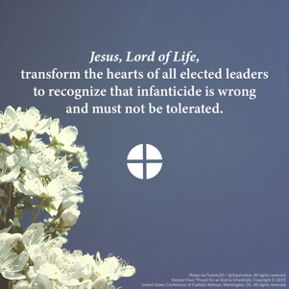  Download
May 12th  “If you experience difficulty bringing a child into your family, know that you are not alone. God is with you, and his Church desires to walk with you… God has a beautiful plan for your life as a married couple. Seek his guidance, and let the healing power of prayer, a conversation in which ‘heart speaks unto heart,’ strengthen you.”  USCCB Secretariat of Pro-Life Activities  “Seven Considerations While Navigating Infertility” | 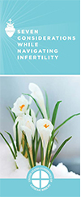  Order | Download
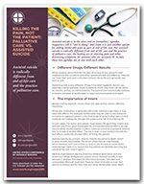
May 19th
“Patients need to be able to trust their doctors to always care for their lives and never deliberately cause death… Patients facing serious illness may feel hopeless and depressed, as though their lives have lost meaning. Addressing psychological, emotional, and spiritual problems is essential to palliative care. Assisted suicide alleviates none of these problems, but gives in to them.”
USCCB Secretariat of Pro-Life Activities
Order | Download
“Killing the Pain, Not the Patient: Palliative Care vs. Assisted Suicide”

May 26th  “Mary, patroness of America, renew in us a love for the beauty and sanctity of the human person from conception to natural death; and as your Son gave His life for us, help us to live our lives serving others. Mother of the Church, Mother of our Savior, open our hearts to the Gospel of life, protect our nation, and make us witnesses to the truth.”  United States Conference of Catholic Bishops  “Living the Gospel of Life” | 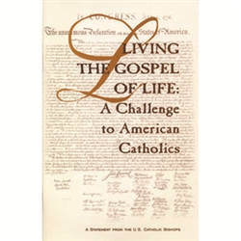  Order | Read Online

Word of Life - May 2019

Bulletin Art
You are welcome to use these and other downloadable images from the online Respect Life image gallery, provided they are not altered in any way, other than the size. Thank you!

Sunday, May 5th, 2019
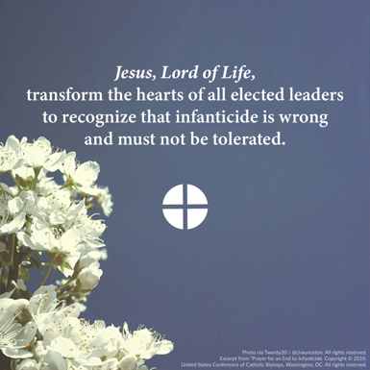
- Image: English | Spanish

Sunday, May 12th, 2019
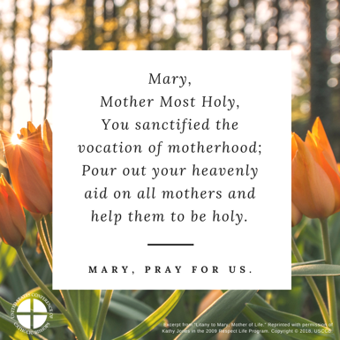
- Image: English | Spanish

Sunday, May 19th, 2019
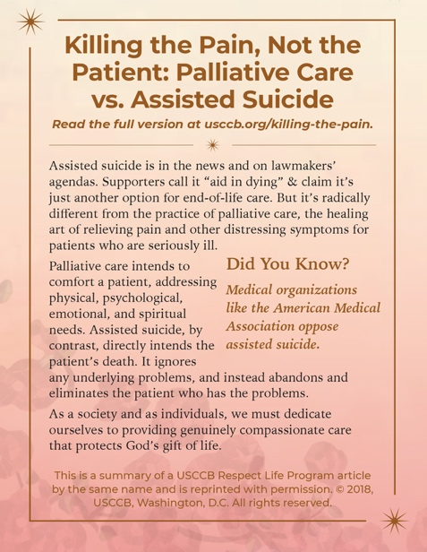
- Bulletin Box: English | Spanish

