Word of Life: June 2019
Recommended dates are provided, but you are welcome to use these materials at any time!

Featured this Month…
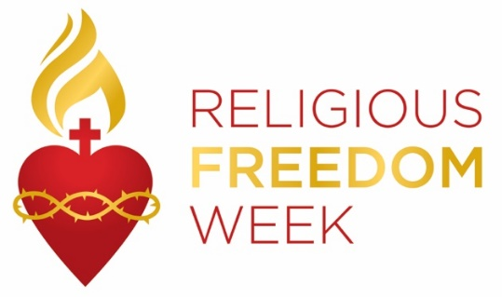
Religious Freedom Week: Strength in Hope
June 22–29, 2019
Religious Freedom Week 2019: Strength in Hope takes place June 22 – 29. The Week begins with the Feast of Sts. John Fisher and Thomas More, ends with the Solemnity of Sts. Peter and Paul, and includes the Feast of the Nativity of St. John the Baptist. This year’s Religious Freedom Week is also notable in that it includes the Solemnity of the Most Holy Body and Blood of Christ (Corpus Christi) and the Solemnity of the Sacred Heart of Jesus.
Many resources are available to help the faithful pray, reflect, and take action on religious liberty, both here in this country and abroad.
These materials include the following:
- Bulletin Insert
- Lectionary Notes
- Sunday, June 23, 2019: Solemnity of Corpus Christi
- Sunday, June 30, 2019: Sunday before Independence Day
- Graphics
- Promotional Video (2-3 minutes)
- Pray-Reflect-Act Series
A one-pager features a different topic each day of Religious Liberty Week. These materials help people learn about religious liberty from a Catholic perspective, pray about particular issues, and act on what they learn
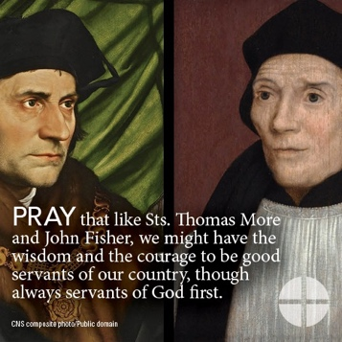
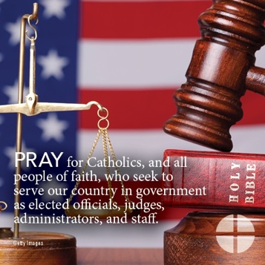
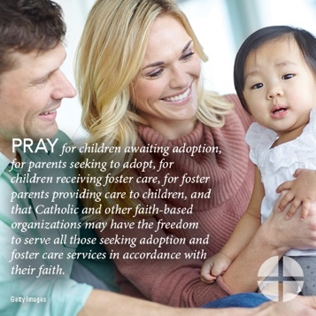
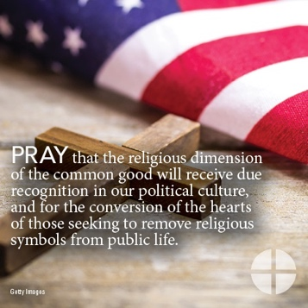
All materials are available at www.usccb.org/ReligiousFreedomWeek. (Spanish-language versions are available for most resources on the same webpage.)

Word of Life – June 2019
Intercessions for Life
June 2nd  For all children in the womb:  May they be seen as gifts from the Father,  and gifts for the world;  We pray to the Lord: | The Ascension of the Lord (or in some places: Seventh Sunday of Easter)
June 9th  For newly confirmed Catholics:  May they be open to the Holy Spirit  and courageously stand for the protection of all human life;  We pray to the Lord: | Pentecost Sunday
June 16th  For work towards medical and scientific advancement:  May God’s Spirit of truth guide these efforts,  that discoveries may never come at the expense of human life;  We pray to the Lord: | The Solemnity of the Most Holy Trinity
June 23rd  For all who are persecuted because of their faith:  May they be freed from persecution and violence,  and find safety, refuge, and peace;  We pray to the Lord: | The Solemnity of the Most Holy Body and Blood of Christ
June 30th  For our nation and our civic leaders:  May they respect the right to live out our Faith  and support laws and policies that protect human life;  We pray to the Lord: | Thirteenth Sunday in Ordinary Time

Word of Life – June 2019

Bulletin Quotes
June 2nd  “By 18 weeks in your mother’s womb, you could swim, somersault, suck your thumb, and even cover your ears if you heard loud music.”  USCCB Secretariat of Pro-Life Activities  “Another Look at Abortion” | 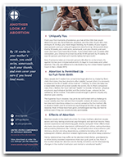  Order | Download
June 9th  “You who are my messenger, in you I place my absolute trust.”  - Our Lady of Guadalupe to St. Juan Diego  USCCB Secretariat of Pro-Life Activities  2018-2019 Respect Life Program Poster | 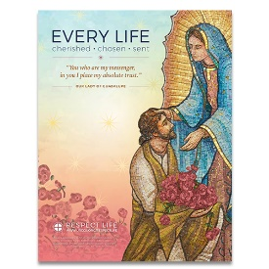  Order | Download
June 16th  “Each [IUI and IVF] procedure involved living human beings— individuals with unique DNA, who deserve to be treated with the dignity of human persons. … They should no more be frozen or disposed of like laboratory waste than the rest of us. They bear—as all human beings do—the image and likeness of God, the Father of all.”  USCCB Secretariat of Pro-Life Activities  “Life Matters: Reproductive Technology” |  | Order | Download
June 23rd  “Religious freedom gives us the space to carry out the mission that Jesus has entrusted to the Church. Religious freedom means that Catholics, and all people of goodwill, are free to seek the truth and to live in accordance with that truth, and so to strengthen our common life as a nation.”  United States Conference of Catholic Bishops  Download Bulletin Insert  “Bulletin Insert: Religious Freedom Week 2019” | 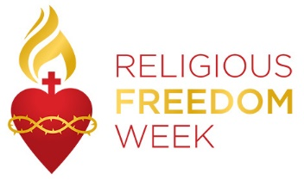
June 30th  “The purpose of freedom is that we might be servants of one another. Life in the Spirit is always oriented toward love and service for others.”  United States Conference of Catholic Bishops  Religious Freedom Week 2019 | Lectionary Notes: June 30, 2019

Word of Life - June 2019

Bulletin Art
You are welcome to use these and other downloadable images from the online Respect Life image gallery, provided they are not altered in any way, other than the size. Thank you!

Sunday, June 2nd, 2019
- Image: Color | Grayscale
- Additional formats (Word, Publisher) of the bulletin box are also available online.
- “Another Look at Abortion” (full article): Order | Download
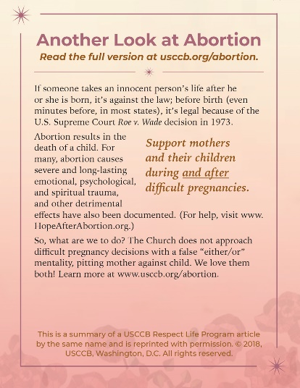

Sunday, June 23rd, 2019

- Image: English | Spanish
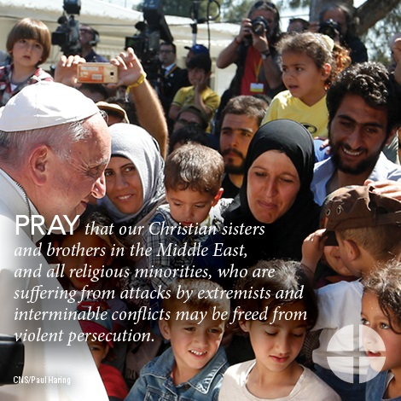
- Pray-Reflect-Act for Sunday, June 23, 2019

