Word of Life: October 2019
Recommended dates are provided, but you are welcome to use these materials at any time!
Respect Life Month
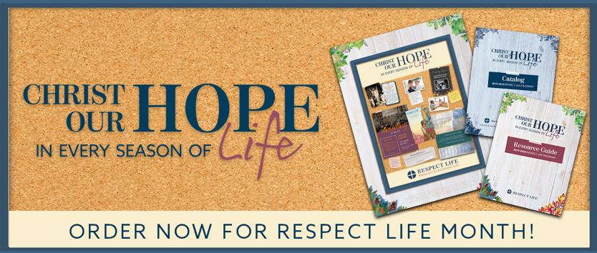
The 2019–20 Respect Life Program resources have been developed to assist you in helping Catholics understand, value, and become engaged with building a culture that cherishes every human life.
A variety of materials are available to order in print or to download online!

Featured Resources
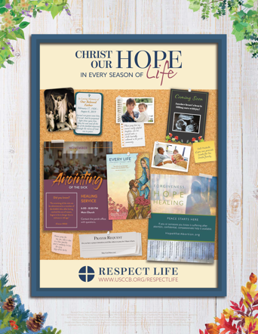
- Respect Life Month Action Guide (action ideas, homily helps, a sample timeline & more!)
- 2019-20 Respect Life Reflection
- Bulletin Cover | Bulletin Wrapper
- Homily Helps
- Bulletin Boxes

Sample Pulpit Announcements

Option 1: Respect Life Sunday (October 6)

This weekend, the Church in the United States celebrates Respect Life Sunday, kicking off Respect Life Month. See this week’s bulletin for more information and a short reflection on this year’s theme.

Option 2: Respect Life Month

Each October, the Church in the United States celebrates Respect Life Month. See this week’s bulletin for more information and a short reflection on this year’s theme, “Christ Our Hope: In Every Season of Life.”

Sample Bulletin Announcements
Option 1: Respect Life Sunday (October 6)
Today is Respect Life Sunday!
Join Catholics nationwide in celebrating the kickoff of Respect Life Month. Find the reflection on this year’s theme, “Christ Our Hope: In Every Season of Life” by visiting respectlife.org/reflection.
Option 2: Respect Life Month
October is Respect Life Month!
Join Catholics nationwide in celebrating throughout October. Learn more about upholding the sanctity of every human life at respectlife.org/respect-life-month.

Word of Life – October 2019
Intercessions for Life
October 6th  For all Catholics:  That on this Respect Life Sunday  we may recommit ourselves  to upholding the dignity  of every human life;  We pray to the Lord: | Twenty-seventh Sunday  in Ordinary Time  (Observed in the U.S. as  Respect Life Sunday)
October 13th  For all who have been wounded  by participating in abortion:  May they receive healing in  Christ’s mercy and glorify the Lord;  We pray to the Lord: | Twenty-eighth Sunday  in Ordinary Time
October 20th  For those who work to defend human life:  May they persevere in their efforts,  always seeking the help of the Lord,  the giver of life;  We pray to the Lord: | Twenty-ninth Sunday  in Ordinary Time
October 27th  During this Respect Life Month and always,  may our hope in Christ’s resurrection  strengthen us in standing up for  the gift of human life;  We pray to the Lord: | Thirtieth Sunday  in Ordinary Time

Word of Life – October 2019

Bulletin Quotes

October 6th  “When the seas of life swell and we are battered by the waves, hope allows us to remain anchored in the heart of God. May we hold fast to Christ our hope, from the beginning of life to its very end.”  USCCB Secretariat of Pro-Life Activities  2019-20 Respect Life Reflection  www.respectlife.org/reflection | 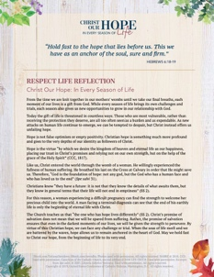  PDF | Word
October 13th  “With the help of an abortion healing ministry, couples can successfully work through abortion-related challenges. God’s grace can bring true healing to the relationships of those who trust in His infinite mercy.”  USCCB Secretariat of Pro-Life Activities  “Healing within Marriage from an Abortion”  www.respectlife.org/healing-in-marriage | 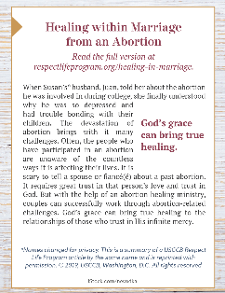  Order | Download
October 20th  “This year’s theme, Christ Our Hope: In Every Season of Life, is particularly suited for the times in which we live. The attacks against human life seem to grow more numerous and callous by the day. Despite these challenges, we know that Christ has conquered sin and death once and for all. Through our Christian hope in the Resurrection, we are given the grace to persevere in faith. Our sacrifices on behalf of the Gospel of Life can contribute to the redemption of this current culture of death.”  Archbishop Joseph F. Naumann, Chairman  USCCB Committee on Pro-Life Activities  https://www.respectlife.org/letter-from-our-chairman | 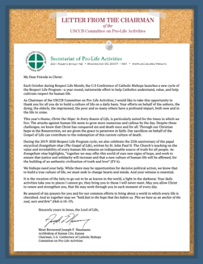  PDF | Word
October 27th  “An unexpected pregnancy can be a difficult and frightening time, and it's important that your friend knows you are thinking of her and supporting her… Your support might be the only support she receives. Even if we never know how, the smallest things we do can change someone's life. You can make a difference in her life. Will you?”  USCCB Secretariat of Pro-Life Activities,  “10 Ways to Support Her When She’s Unexpectedly Expecting”  www.respectlife.org/support-her | 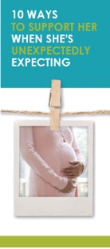  Order | Download

Word of Life – October 2019

Bulletin Art
You are welcome to use these and other downloadable images from the online Respect Life image gallery, provided they are not altered in any way, other than the size. Thank you!

Sunday, October 6th, 2019
Featuring Reflection: “Christ Our Hope: In Every Season of Life”
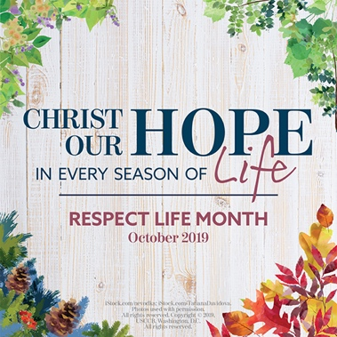
- Respect Life Reflection: PDF | Word
- Download Image: English | Spanish

Sunday, October 13th, 2019
Featuring “Healing within Marriage from an Abortion”
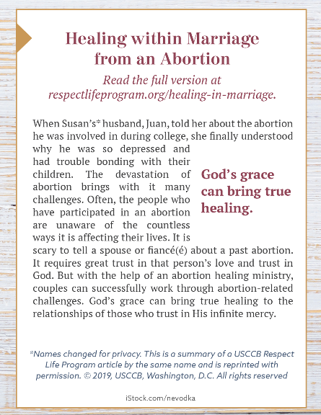
- Bulletin Box (color): English | Spanish
- Bulletin Box (grayscale): English | Spanish
- Bulletin Box (text-only): English | Spanish

Sunday, October 20th, 2019
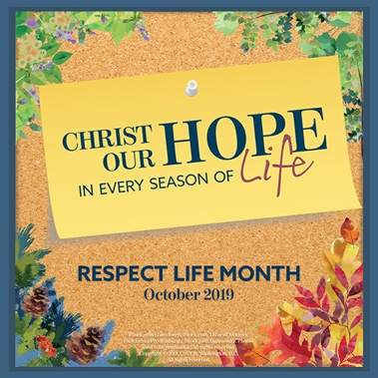
- Download Image: English | Spanish

