Word of Life: May 2020
Recommended dates are provided, but you are welcome to use these materials at any time!
Special Note
Despite shutdowns of public Masses and in-person events to mitigate the spread of COVID-19, many of these resources may still be useful and adaptable for digital efforts or for use at another time.
For example, you could share the intercessions with your pastor for use during live-streamed Masses or include one a week in newsletters. You might consider incorporating some of the quotes or graphics in emails or text messages and/or posting them on social media. For easy social media content, you can also share posts from the USCCB Pro-Life Office’s Facebook (People of Life) and Twitter (@usccbprolife) accounts.
Similarly, resources and timelines in the Mother’s Day action guide and Walking with Moms in Need are also flexible and adaptable.

Featured this Month…

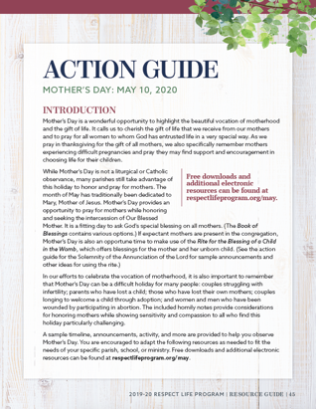
Mother’s Day: May 10, 2020
Mother’s Day is a wonderful opportunity to highlight the beautiful vocation of motherhood and the gift of life. It calls us to cherish the gift of life that we receive from our mothers and to pray for all women to whom God has entrusted life in a very special way. We also specifically remember mothers experiencing unexpected or difficult pregnancies and pray they may find support and encouragement in choosing life for their children. Our May Action Guide features homily helps, announcements, and more to assist with honoring and praying for mothers in your parish community.

Pray for Life: May
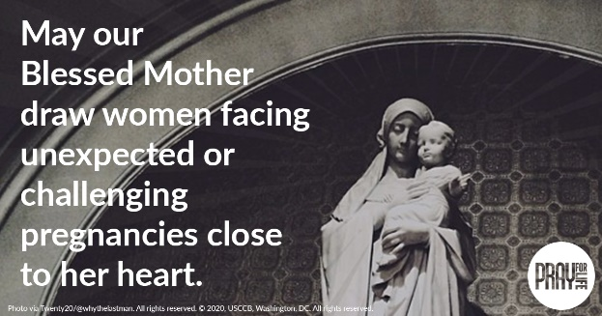
Join us in praying for expectant mothers facing difficulties through the intercession of our Blessed Mother! www.usccb.org/pray
Prayer Guide: English | Spanish

Word of Life – May 2020
Intercessions for Life
Example adaptations of intercessions for use during COVID-19 (and beyond)
- Share with your pastor for use during live-streamed Masses.
- Include one intention each week in parish emails and/or text messages.
- Post one a week on your parish website.
- Send to members of your parish prayer ministry group and your parish pro-life ministry group, asking them to pray for the weekly intercessions.
- Include the weekly intercession in the parish bulletin.
May 3rd  For persons with disabilities:  May their lives always be recognized  as worth protecting and fighting for,  especially during times of widespread illness;  We pray to the Lord: | Fourth Sunday of Easter
May 10th  For all mothers:  May they be supported and encouraged  as they fulfill their vocation,  especially during this difficult time;  We pray to the Lord: | Fifth Sunday of Easter
May 17th  May our elected officials  always strive to keep the Lord’s Commandments  and work for the protection of human life,  from conception to natural death;  We pray to the Lord: | Sixth Sunday of Easter
May 24th  For all Christians:  That our example may give witness to  the precious gift of human life in this world and  the invitation to eternal life in the next;  We pray to the Lord: | The Ascension of the Lord  (or the Seventh Sunday of Easter where applicable)
May 31st  May the Holy Spirit strengthen God’s people  to embrace and protect the precious gift of human life;  We pray to the Lord: | Pentecost Sunday

Word of Life – May 2020
Bulletin Quotes
Example adaptations of bulletin quotes for use during COVID-19 (and beyond)
- Share with your pastor for use in weekly messages or homilies.
- Include one quote each week in parish bulletins, emails, and/or text messages.
- Post one a week on your parish website and/or social media.
May 3rd  “Even the weakest and most vulnerable, the sick, the old, the unborn and the poor, are masterpieces of God’s creation, made in his own image, destined to live forever, and deserving of the utmost reverence and respect.”  USCCB Respect Life flyer quoting Pope Francis’ “Day for Life Greeting”  © 2013 Libreria Editrice Vaticana. Used with permission. All rights reserved. | Download
May 10th  “O Blessed Mother, you received the good news of the incarnation of Christ, your Son, with faith and trust. Grant your protection to all pregnant mothers facing difficulties.”  USCCB Secretariat of Pro-Life Activities,  “A Prayer for Pregnant Mothers” | View, Download, or Order
May 17th  “As Americans, as Catholics and as pastors of our people, we write therefore today to call our fellow citizens back to our country's founding principles, and most especially to renew our national respect for the rights of those who are unborn, weak, disabled and terminally ill. Real freedom rests on the inviolability of every person as a child of God.”  United States Conference of Catholic Bishops  “Living the Gospel of Life,” © 1998 USCCB. | 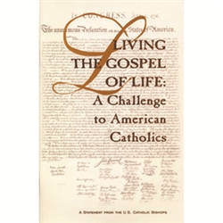  Order | Read Online
May 24th
“Everyone is in need of reassurance, and if we, who have touched ‘the Word of life’ (1 Jn 1:1) do not give it, who will? How beautiful it is to be Christians who offer consolation, who bear the burdens of others and who offer encouragement: messengers of life in a time of death!”
Pope Francis, 2020 Easter Vigil Homily
© 2020 Libreria Editricea Vaticana. Used with permission. All rights reserved.
May 31st  “God creates us in his image and likeness, which means we are made to be in loving relationship with him. The essence of our identity and worth, the source of our dignity, is that we are loved by God.”  USCCB Secretariat of Pro-Life Activities  “How to Build a Culture of Life” | Order | Download

Word of Life – May 2020
Bulletin Art
You are welcome to use these and other downloadable images from the online Respect Life image gallery, provided they are not altered in any way, other than the size. Thank you!
Example adaptations of bulletin art for use during COVID-19 (and beyond)
- Include in parish emails.
- Post on your parish website.
- Include in the parish bulletin.
- Post on social media (or share from People of Life on Facebook or @usccbprolife on Twitter).

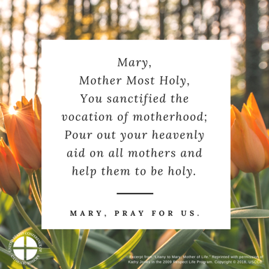
Sunday, May 10th, 2020
Download Image: English | Spanish

Sunday, May 17th, 2020
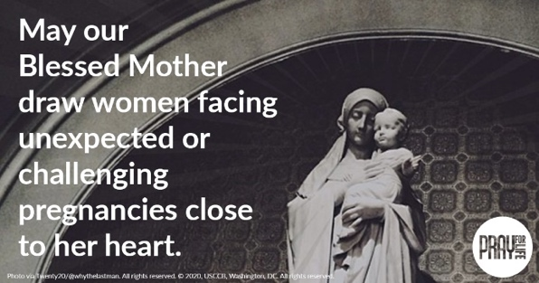
- Download Image: English | Spanish
- Prayer Guide: English | Spanish

