Word of Life: June 2020
Recommended dates are provided, but you are welcome to use these materials at any time!
Featured this Month…
Father’s Day Action Guide
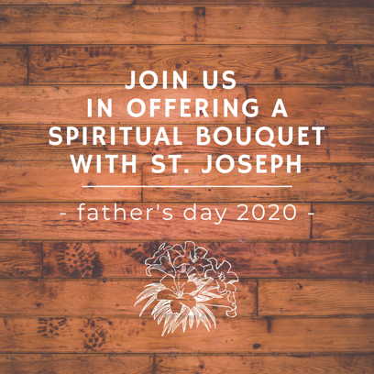
June 21, 2020
Although Father’s Day is not a liturgical observance, it is an appropriate time to underscore the essential role of fathers in the life of the family and in building a culture of life. It is also an opportunity to highlight spiritual fatherhood, which all men are called to embrace.

Simple steps, sample intercessions, homily considerations, and an activity are provided in the Father’s Day Action Guideto help your parish celebrate and pray for the fathers in your community, whether you are able to gather in person or are socially distancing. Please feel free to adapt the following resources to fit the needs of your specific parish or ministry.

Religious Freedom Week: For the Good of All
June 22-29, 2020
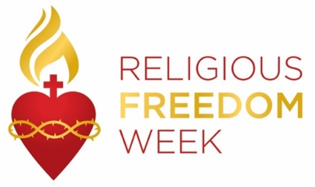
Religious Freedom Week 2020: For the Good of All takes place June 22 – 29. The Week begins with the Feast of Sts. John Fisher and Thomas More, ends with the Solemnity of Sts. Peter and Paul, and includes the Feast of the Nativity of St. John the Baptist. Many resources are available to help the faithful pray, reflect, and take action on religious liberty, both here in this country and abroad. Resources, including graphics, lectionary notes, bulletin inserts, and daily prayers and reflections are available at usccb.org/ReligiousFreedomWeek.

Pray for Life: June

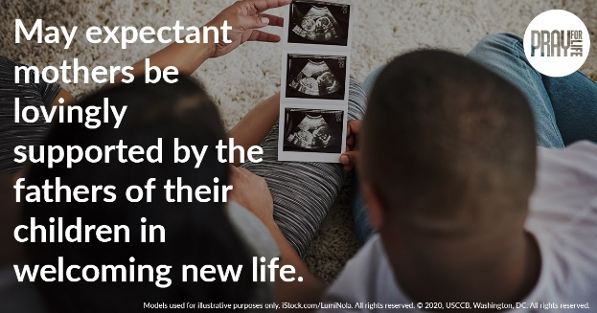
Join us in praying that expectant mothers will be lovingly supported by the fathers of their children in welcoming new life.

Print Reflection: English
Graphic: English | Spanish

Word of Life – June 2020
Intercessions for Life
June 7th  May society come to a deeper understanding and respect  for the human person,  who is created by the Father,  redeemed by the Son,  and made holy by the grace of the Holy Spirit;  We pray to the Lord: | The Solemnity of the Most Holy Trinity
June 14th  May increased devotion to Jesus,  hidden, yet physically present in the Eucharist,  deepen our care for unborn children,  hidden beneath the hearts of their mothers;  We pray to the Lord: | Solemnity of the Most Holy Body and Blood of Christ (Corpus Christi)
June 21st  May expectant fathers lovingly support  the mothers of their children  in welcoming new life;  We pray to the Lord: | Twelfth Sunday in Ordinary Time
June 28th  For married couples longing for a child:  May God grant them the grace and strength  to place their faith in His loving plan;  We pray to the Lord: | Thirteenth Sunday in Ordinary Time

Word of Life – June 2020

Bulletin Quotes

June 7th  “The Gospel of Life is at the heart of Jesus’ saving message to the world. Through the Incarnation of Christ, God reveals to us the dignity of all human life.’”  USCCB Secretariat of Pro-Life Activites  “Pope St. John Paul II’s Challenge to Our Church” | 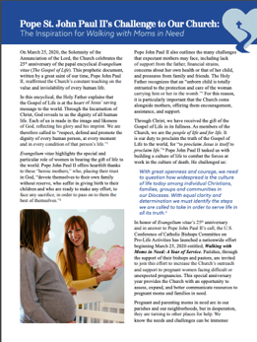  Download
June 14th  Our relationship with Christ—strengthened by receiving him worthily in Holy Communion—helps us understand our relationships with one another and with creation.  USCCB Secretariat of Pro-Life Activites  “Serene Attentiveness to God’s Creation” | 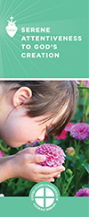  Order | Read Online
June 21st  “Through our prayers and through the intercession of St. Joseph, patron of fathers, may fathers come to know the irreplaceable role they hold in the lives of their children, and the responsibility they share in welcoming God’s gift of new life!  USCCB Secretariat of Pro-Life Activities  “Pray for Life: June 2020” quoting Most Reverend Fabre, Bishop of Houma-Thibodaux | Download  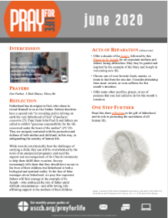
June 28th  “We often assume parenthood happens easily after ‘I do,’ but for many married couples, it does not. For some, the joy of conception never happens. Others suffer repeated miscarriages. Still others experience secondary infertility: after giving birth to one or more children, they are unable to have another… If you experience difficulty bringing a child into your family, know that you are not alone. God is with you, and his Church desires to walk with you.”  USCCB Secretariat of Pro-Life Activities  “Seven Considerations While Navigating Infertility” | 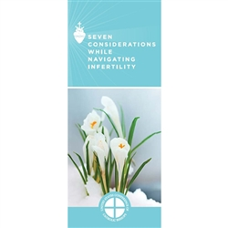  Order | Download

Word of Life – June 2020

Bulletin Art
You are welcome to use these and other downloadable images from the online Respect Life image gallery, provided they are not altered in any way, other than the size. Thank you!

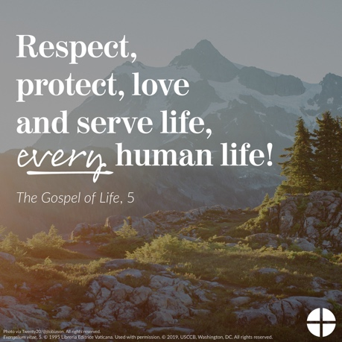
Sunday, June 14th, 2020

- Download Image: English | Spanish

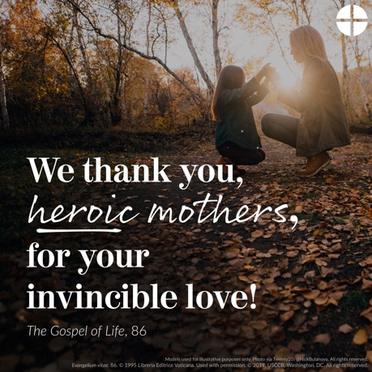
Sunday, June 14th, 2020

- Download Image: English | Spanish

Sunday, June 21st, 2020
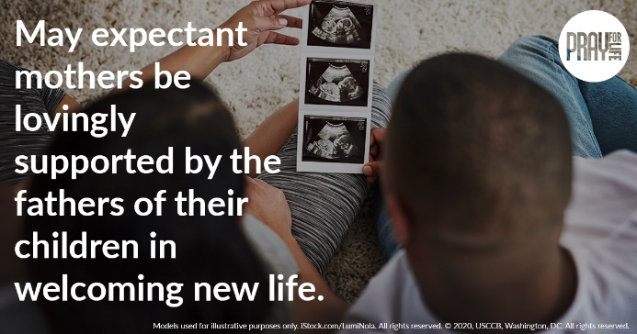
- Download Image: English | Spanish
- Print Reflection: English

