Social Media Tool Kit

Facebook
- Faith fundamentals are a click away with the new online version of the Catechism of the Catholic Church, made possible in part by the Catholic Communication Campaign. Support the collection at Mass! #1church1mission http://goo.gl/ar3E0W
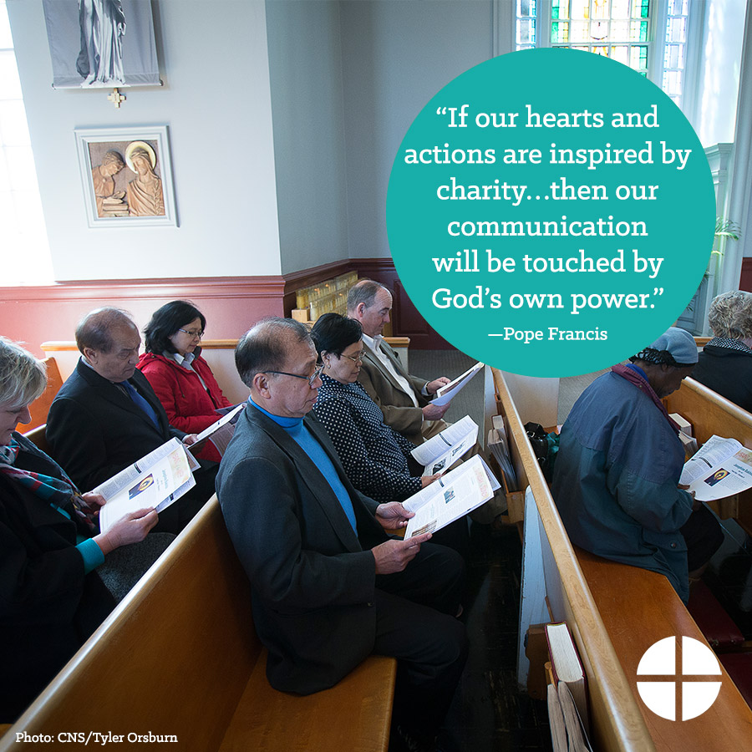
- Check out www.ForYourMarriage.org, and find resources to support you in every step of your relationship, from dating to engaged to married. This website was created with funding from the Catholic Communication Campaign. Support the collection at Mass! #1church1mission

- www.USCCB.org brings you daily readings and reflections, videos, Catholic news, and more thanks to the Catholic Communication Campaign. Please be generous at Mass! #1church1mission
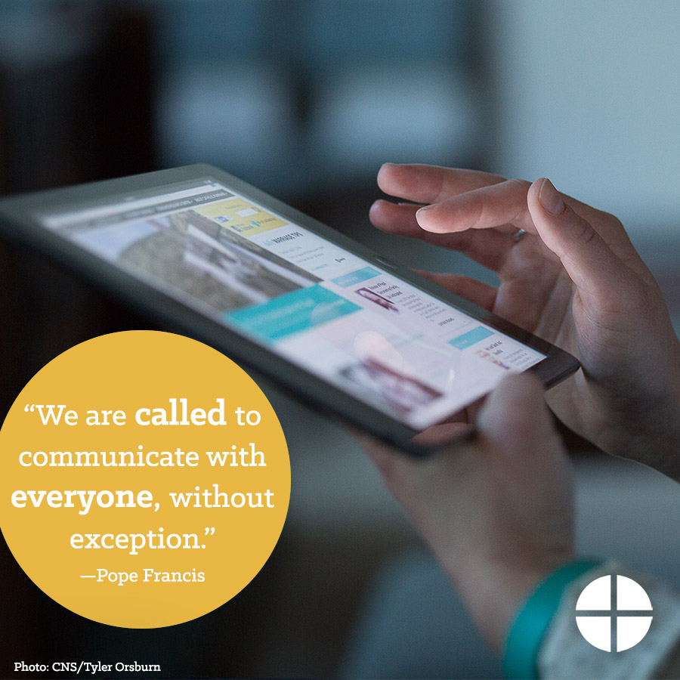

- Get the daily readings straight to your inbox, brought to you by the Catholic Communication Campaign. Please support the collection this weekend! #1church1mission http://goo.gl/CwxB1F

- The Catholic Communication Campaign is this weekend! Half of the proceeds stay here in the diocese to support our communications projects, while the other half supports national and international communications efforts! Please be generous! #1church1mission http://goo.gl/GnQB9O
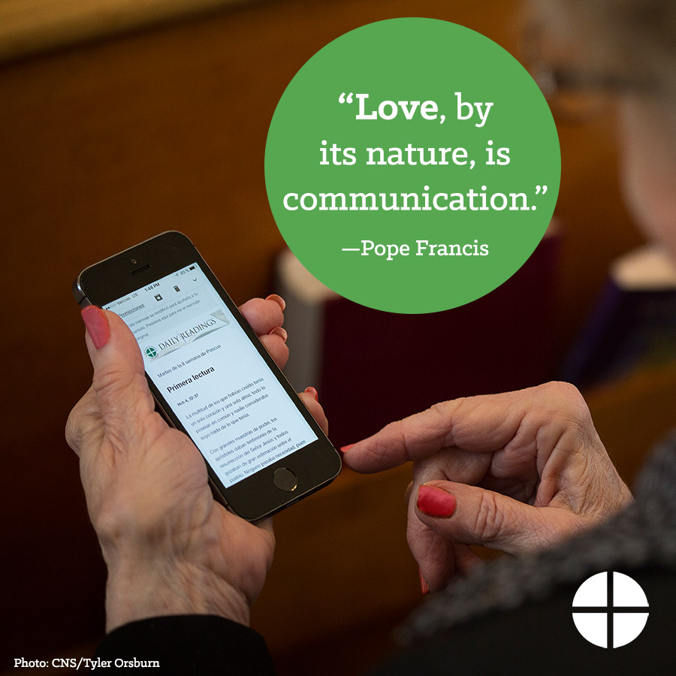

- Learn more about the Catholic Communication Campaign, and support the collection this weekend! #1church1mission http://goo.gl/GnQB9O
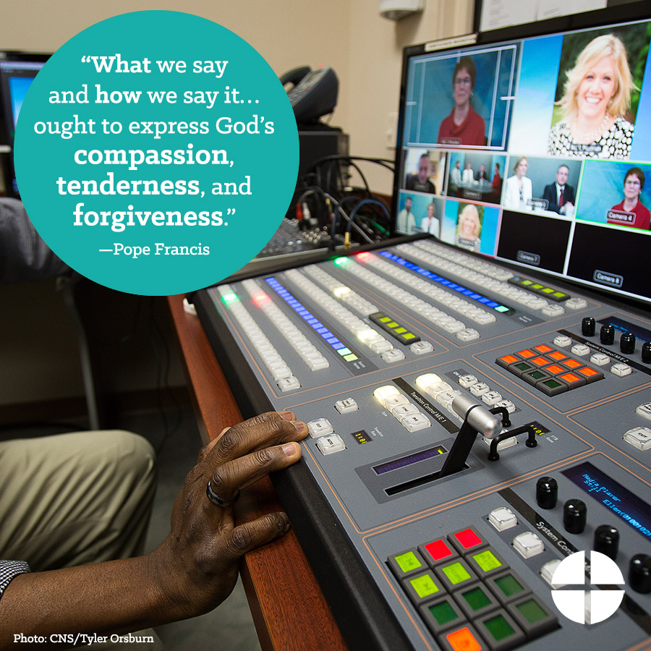

- Do you listen to the daily readings podcasts from the USCCB? This free resource was made possible through your support of the Catholic Communication Campaign. Check it out, and support the collection! http://goo.gl/CwxB1F #1church1mission

- This weekend is the Catholic Communication Campaign. Support the collection, and help share the message of #PopeFrancis! #1church1mission http://goo.gl/GnQB9O
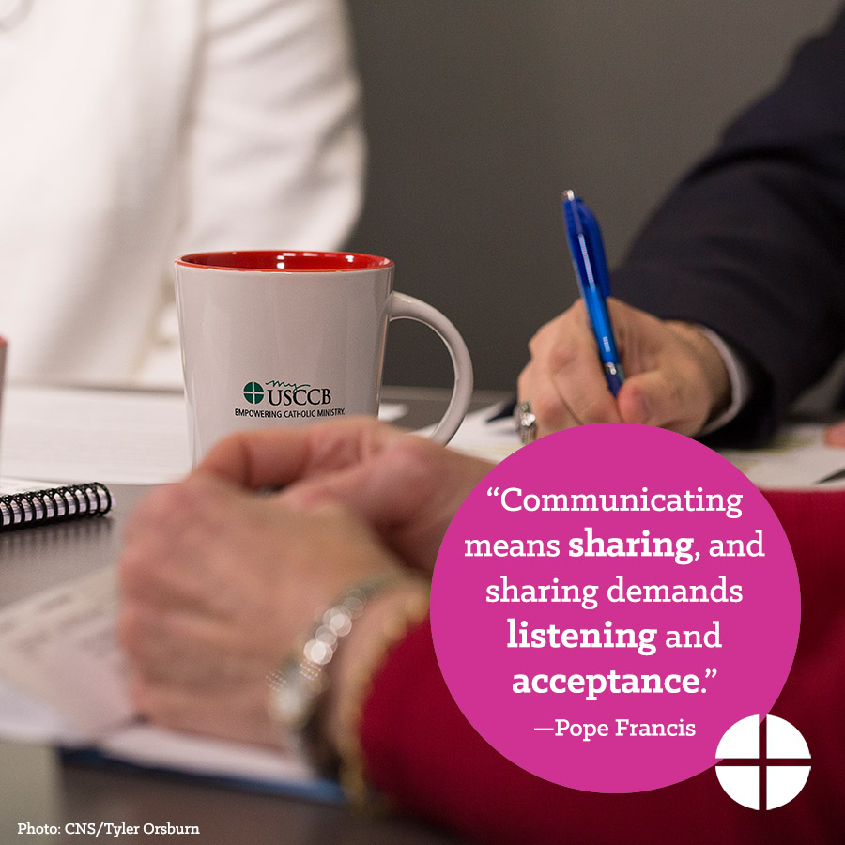

- Today is the Catholic Communication Campaign! Don’t forget to support the collection this weekend and share the good news! #1church1mission http://goo.gl/GnQB9O
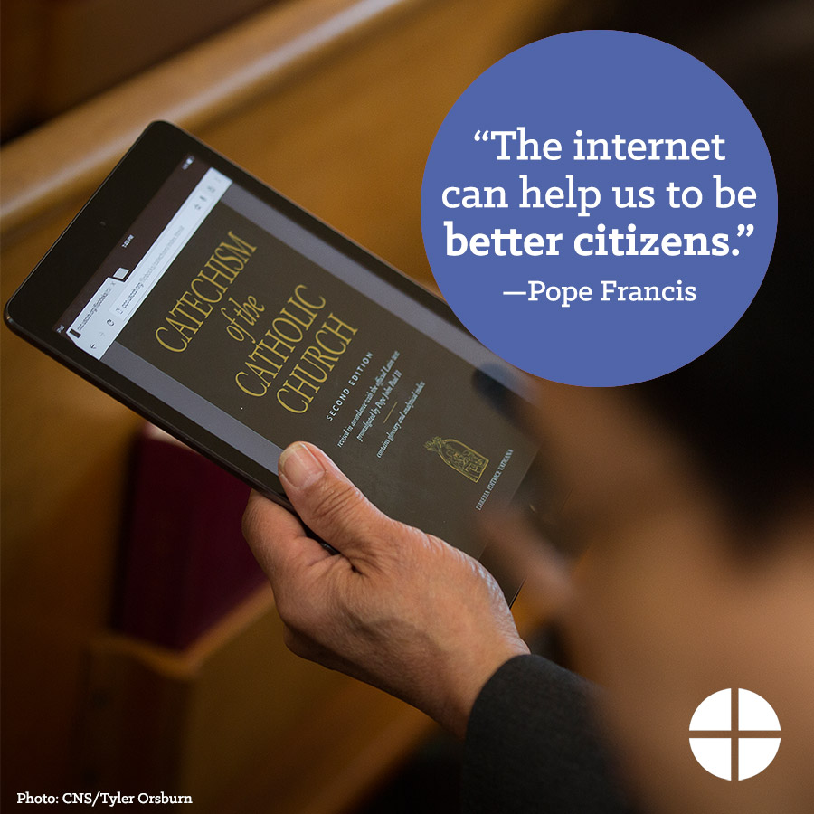

Twitter
- Online Catechism of the Catholic Church made possible by Catholic Communication Campaign. Support the collection! http://goo.gl/ar3E0W
- Share the message of #PopeFrancis & support the Catholic Communication Campaign at Mass! http://goo.gl/GnQB9O
- Resources from @ForYourMarriage support you from dating to engaged to married. Support the Catholic Communication Campaign at Mass!
- Check out these free daily readings podcasts, and support the Catholic Communication Campaign at Mass. http://goo.gl/CwxB1F
- The Catholic Communication Campaign is this weekend! Support the collection at Mass #1church1mission http://goo.gl/GnQB9O

- Learn about the Catholic Communication Campaign, and support the collection at Mass! #1church1mission http://goo.gl/GnQB9O
- Support the Catholic Communication Campaign this weekend and share the message of #PopeFrancis! #1church1mission http://goo.gl/GnQB9O
- Today is the Catholic Communication Campaign! Support the collection at Mass! #1church1mission http://goo.gl/GnQB9O

Instagram
- Your support of the Catholic Communication Campaign brings the message of #PopeFrancis to all. Give to the collection at Mass! #1church1mission
- Support the Catholic Communication Campaign at Mass this weekend, and connect people around the world with Christ. #1church1mission

- Support the Catholic Communication Campaign at Mass this weekend to help spread the gospel message! Half of the collection stays in our diocese to fund communications projects. The other half supports national and international communication efforts! #1church1mission
- Communicate mercy, and support the Catholic Communication Campaign at Mass this weekend! Your support makes it possible to share the message of #PopeFrancis. #1church1mission

- This weekend is the Catholic Communication Campaign! Support the collection, and connect with Christ! #1church1mission

- This weekend is the Catholic Communication Campaign. Support the collection, and help share the message of #PopeFrancis! #1church1mission

