Social Media Tool Kit

Post 1: Before the Collection
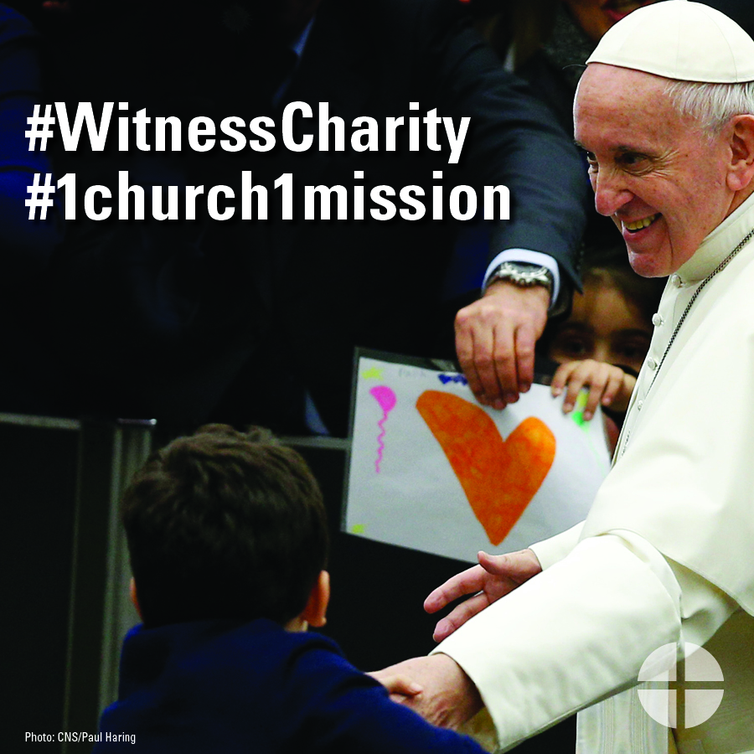
Facebook/Instagram/Twitter:
Do you follow #PopeFrancis as he travels the world to help the suffering? Support the Peter’s Pence Collection to help his message of mercy travel even further. #WitnessCharity #1church1mission
www.usccb.org/peters-pence

Post 2: Before the Collection
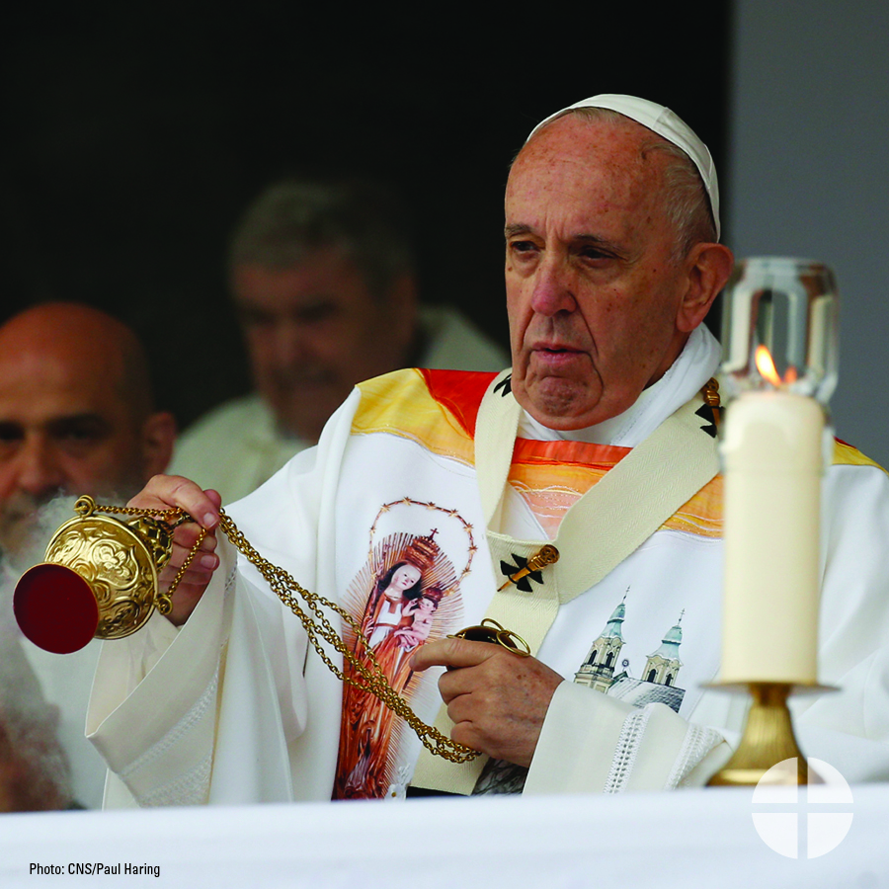
Facebook/Twitter:
Learn more about the Peter’s Pence Collection and support #PopeFrancis and his works! #WitnessCharity #1church1mission www.usccb.org/peters-pence

Post 3: Before the Collection
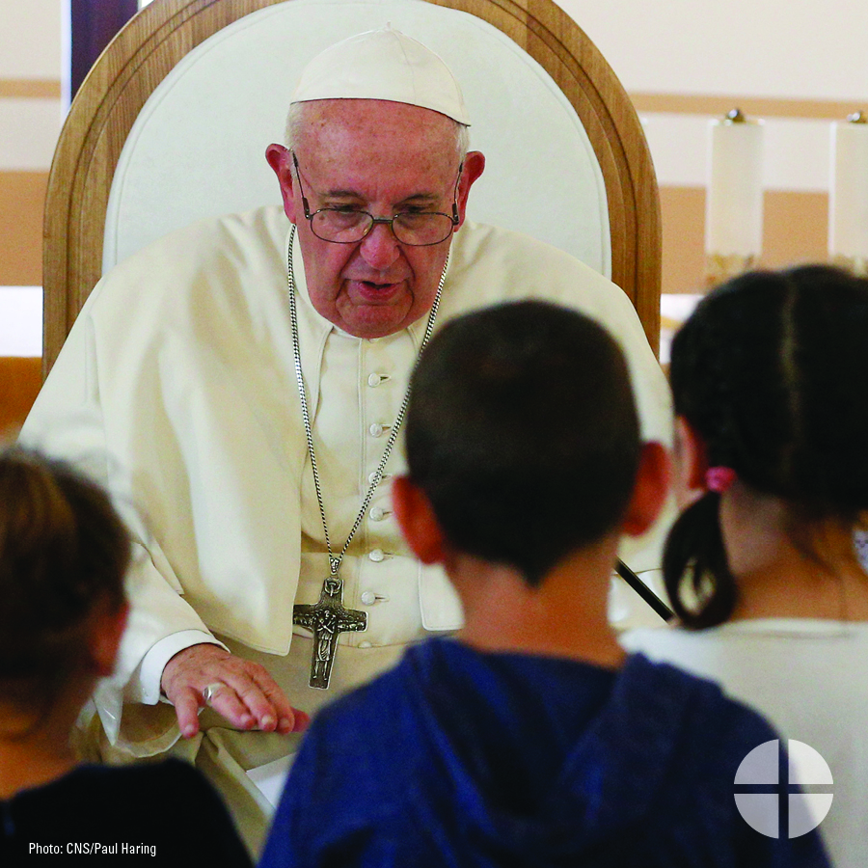
Facebook/Instagram/Twitter:
Contributions to the Peter’s Pence Collection support the charitable works of #PopeFrancis as he reaches out to victims of war and natural disaster. Support the collection at Mass! #WitnessCharity #1church1mission www.usccb.org/peters-pence

Post 4: Before the Collection
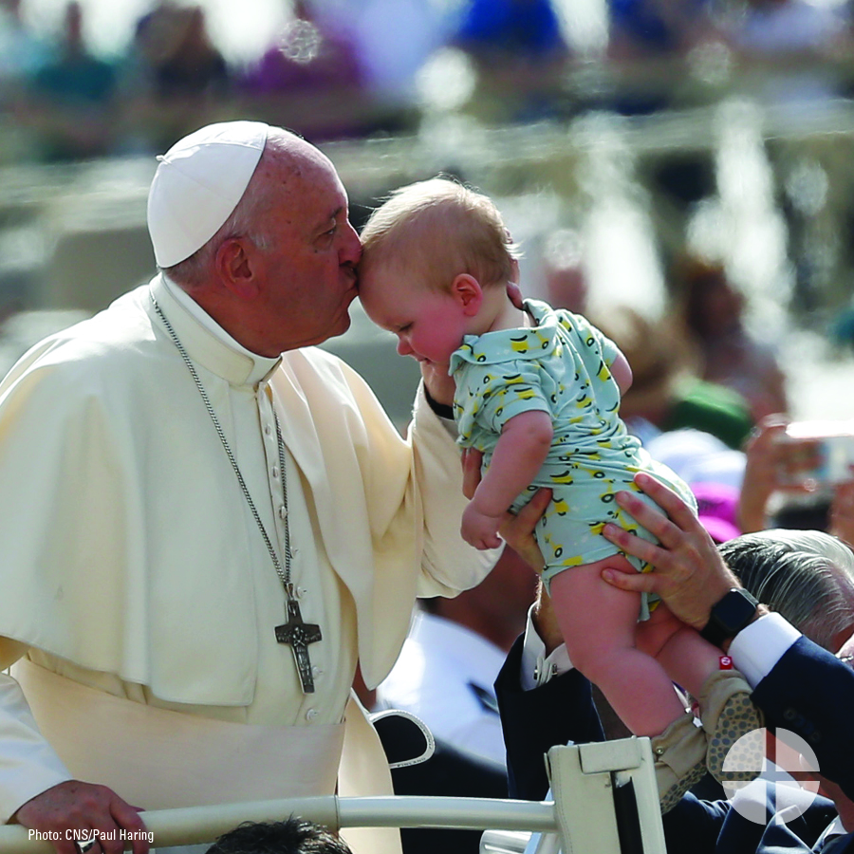
Facebook/Instagram/Twitter:
Your support of the Peter’s Pence Collection directly helps #PopeFrancis support his charitable works. Give at Mass to spread his message of mercy! #WitnessCharity #1church1mission
www.usccb.org/peters-pence

Post 5: Week of the Collection
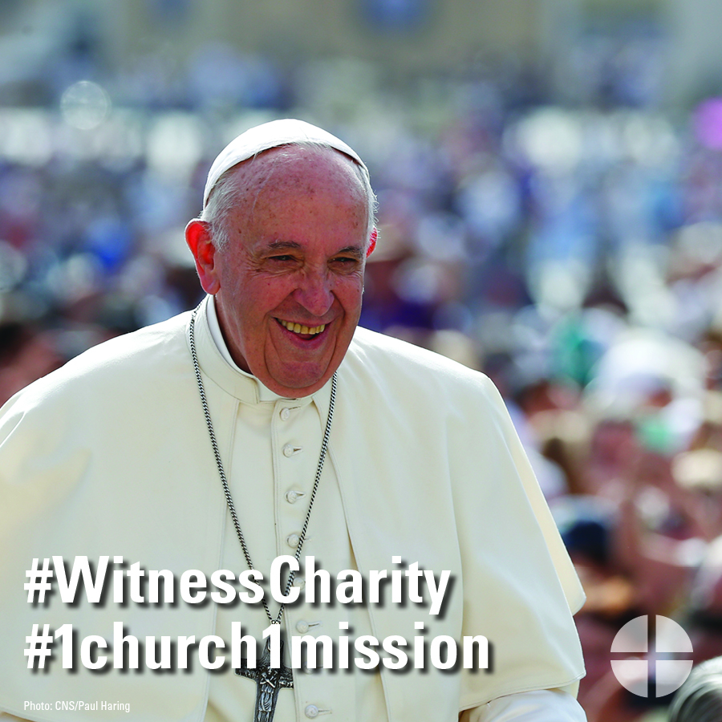
Facebook/Instagram/Twitter:
Help #PopeFrancis continue his charitable works. Support the Peter’s Pence Collection this weekend at Mass! #WitnessCharity #1church1mission
www.usccb.org/peters-pence

Post 6: Week of the Collection
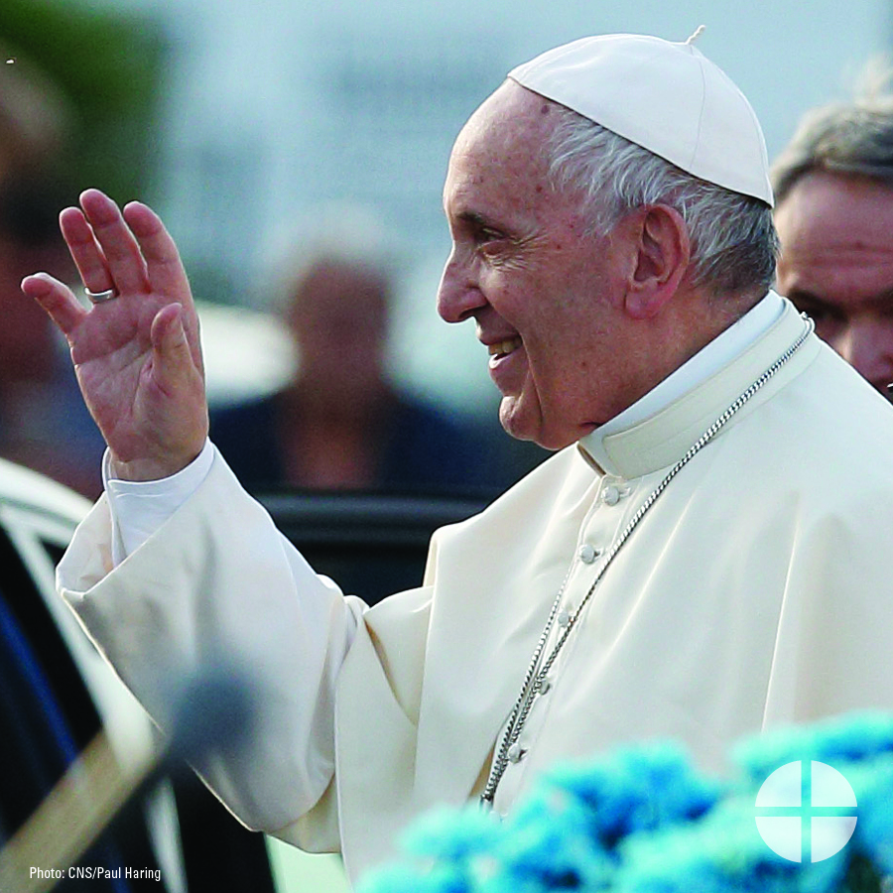
Facebook/Twitter:
Did you know the Peter’s Pence Collection is rooted in ancient Christianity? Learn more about this collection and #WitnessCharity by supporting it this weekend at Mass! #1church1mission http://www.usccb.org/peters-pence

Post 7: Week of the Collection
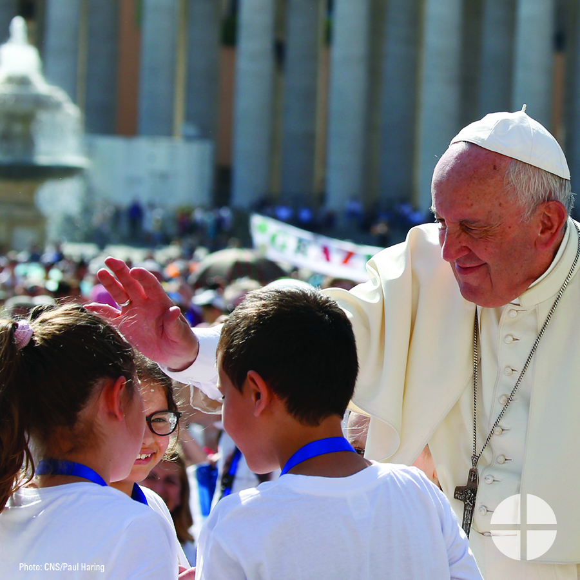
Facebook/Instagram/Twitter:
When you support the Peter’s Pence Collection, you support #PopeFrancis and his works. Please be generous at Mass this weekend! #WitnessCharity #1church1mission www.usccb.org/peters-pence

Post 8: Day of the Collection
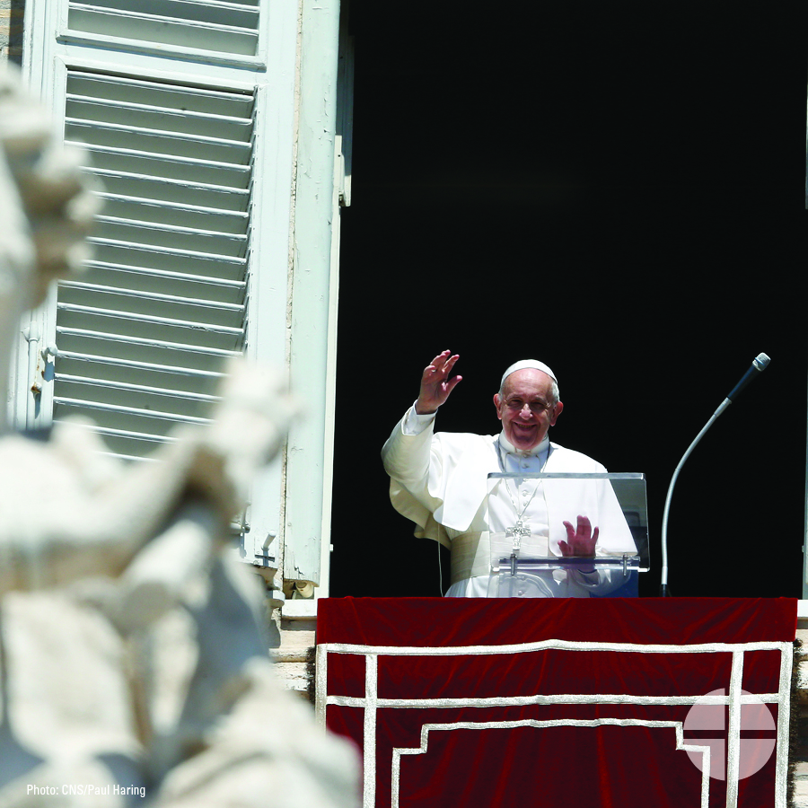
Facebook/Instagram/Twitter:
Today is the Peter’s Pence Collection! Your generosity will support Pope Francis’s charitable works. Please prayerfully consider how you can support the collection this year. #WitnessCharity #1church1mission www.usccb.org/peters-pence

