Word of Life: June 2018
Recommended dates are provided, but you are welcome to use these materials at any time!
Featured this Month…
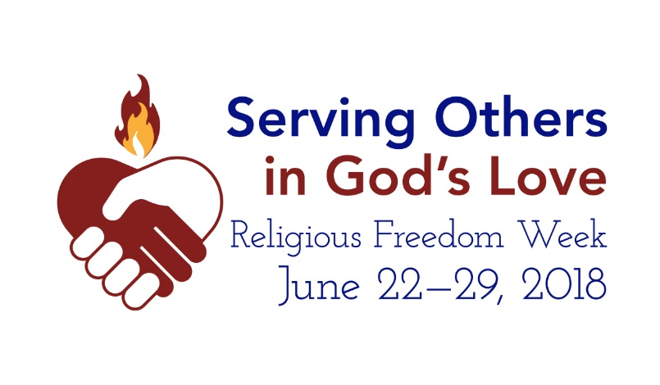
USCCB Religious Liberty Chairman Announces Religious Freedom Week from June 22-29, 2018
April 27, 2018
WASHINGTON—Catholics across the United States are encouraged to pray and act in support of religious liberty at home and abroad during Serving Others in God's Love: Religious Freedom Week 2018, which begins on June 22, the Feast of Sts. Thomas More and John Fisher, and ends on June 29, the Solemnity of Sts. Peter and Paul.
The chairman of the USCCB's Committee for Religious Liberty, Archbishop Joseph E. Kurtz of Louisville, states: "Religious freedom allows the space for people of faith to serve others in God's love in ministries like education, adoption and foster care, health care, and migration and refugee services. We encourage people of faith to reflect on the importance of religious freedom so that we might have the space to carry out our mission of service and mercy, and we invite everyone to pray for our brothers and sisters who face intense persecution in other parts of the world."
Resources for Religious Freedom Week and other religious liberty resources can be found at www.usccb.org/ReligiousFreedomWeek and www.usccb.org/freedom.
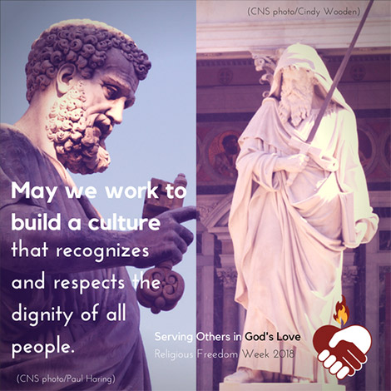
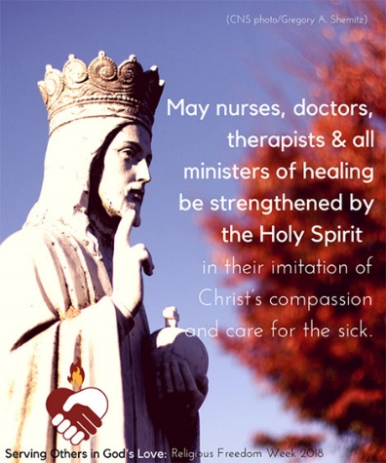
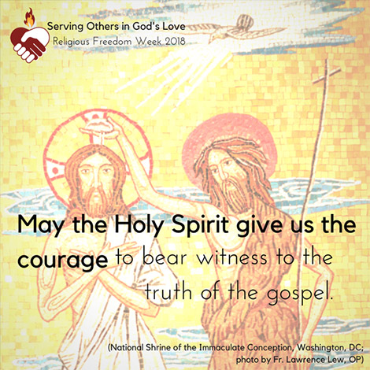

Word of Life – June 2018
Intercessions for Life
The Solemnity of the Most Holy
Body and Blood of Christ

June 3rd
May the grace of the Eucharist,
the body and blood of Jesus,
strengthen our commitment
to protecting the gift of human life;
We pray to the Lord:

June 10th Tenth Sunday in Ordinary Time
For the times we are afraid
to welcome life:
May God strengthen us
and renew our trust in Him;
We pray to the Lord:

June 17th Eleventh Sunday in Ordinary Time
May God, who wonderfully
forms each person in the womb,
protect all unborn children from harm;
We pray to the Lord:

Solemnity of the Nativity
of Saint John the Baptist

June 24th
For our lawmakers:
May they defend our freedom
to follow our consciences in
serving God and neighbor
according to our Faith;
We pray to the Lord:

Word of Life – June 2018

Bulletin Quotes

June 3rd  “In 1943, when France was occupied by German Nazis, the search for Jews began. In the face of grave peril, Sister Agnes convinced her mother superior to open their convent and offer refuge to a Jewish family. …Let us devote ourselves anew to following wherever the Lord leads. Let us take courage from their example of faith.”  USCCB Secretariat of Pro-Life Activities  “Understanding Conscience,” www.bit.ly/understanding-conscience | 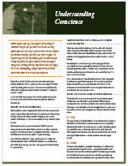  Order Download
June 10th  “To women with an unplanned pregnancy, Maya says, ‘This is survivable. Have hope.’”  USCCB Secretariat of Pro-Life Activities  “Accompanying Expectant Mothers Considering Adoption”  www.usccb.org/women-considering-adoption | 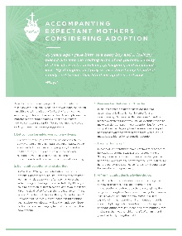  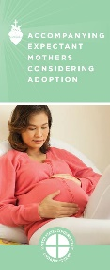  Order Download
June 17th  “If a friend told you she was pregnant and considering abortion, would you know what to do? Learn concrete tips for loving her in a way that is life-affirming for both her and her child.”  USCCB Secretariat of Pro-Life Activities  “What to Do When a Friend Is Considering Abortion”  www.usccb.org/l-o-v-e | Order Download
June 24th  “Religion [cannot] be relegated to the inner sanctum of personal life, without influence on societal and national life.”  Pope Francis, Evangelii gaudium, 183.  © 2013 Libreria Editrice Vaticana. Used with permission. | 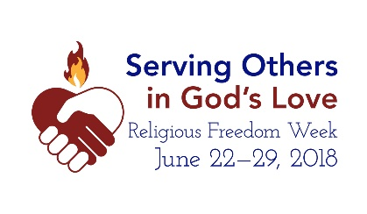  www.usccb.org/  ReligiousFreedomWeek

Word of Life - June 2018

Bulletin Art
You are welcome to use these and other downloadable images from the online Respect Life image gallery, provided they are not altered in any way, other than the size. Thank you!

Sunday, June 3rd, 2018
Featuring “Serene Attentiveness to God’s Creation”
- Image: English | Spanish
- Bulletin Insert: Color | Black-and-White | Grayscale

Sunday, June 24th, 2018
Featuring “Religious Freedom Week 2018”
- Download Image
- More resources! www.usccb.org/ReligiousFreedomWeek

