Word of Life: September 2018
Recommended dates are provided, but you are welcome to use these materials at any time!
Featured this Month…
Novena for the Legal Protection of Human Life
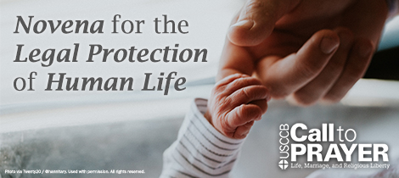
Each Friday, from August 3, 2018 through September 28, 2018, the weekly Call to Prayer is adapted as a nine-week Novena for the Legal Protection of Human Life.
In addition to the current invitation to fast on Fridays, participants are encouraged to pray one Our Father, Hail Mary, and Glory Be for the intention of the novena each week.
Participants are also provided with weekly opportunities to learn more about Roe v. Wade and share that information with their representatives. It’s okay to jump in even after it’s started!
Join at www.usccb.org/pray.
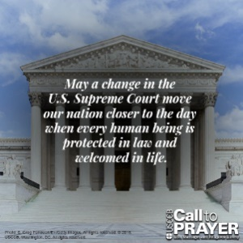
Resources
- Shareable Images

- Fact Sheet: Roe v. Wade: Questions and Answers

- Do You Know Roe?

Sample Pulpit/Bulletin Announcements

Option 1
The U.S. bishops urge our participation each Friday in a nationwide Novena for the Legal Protection of Human Life, August 3–September 28. Participants receive weekly email or text reminders to pray and fast, along with little-known facts about Roe v. Wade to share with others. Sign up at www.usccb.org/pray!

Option 2
Each Friday, August 3–September 28, answer the U.S. bishops’ call to pray and fast that a change in the U.S. Supreme Court will move our nation closer to the day when every human being is protected in law and welcomed in life. Join at www.usccb.org/pray!

Option 3
Each Friday, August 3–September 28, answer the U.S. bishops’ call to education, fasting, and prayer for the legal protection of human life. Join at www.usccb.org/pray!

Word of Life – September 2018
Intercessions for Life
September 2nd Twenty-second Sunday in Ordinary Time
For all who hold public office:
May profound reverence
for the dignity of every person
be deeply rooted in their hearts;
We pray to the Lord:

September 9th Twenty-third Sunday in Ordinary Time
For all who have been harmed by abuse:
May the Holy Spirit heal their wounds
and help them find peace in justice;
We pray to the Lord:

September 16th Twenty-fourth Sunday in Ordinary Time
For all people of goodwill:
May God transform
our respect for human life
into action for its protection;
We pray to the Lord:

September 23rd Twenty-fifth Sunday in Ordinary Time
For all who welcome children
in the face of hardship:
May they find strength
and renewal in Christ;
We pray to the Lord:

September 30th Twenty-sixth Sunday in Ordinary Time
For caregivers of those who are sick or dying:
May they find helpful support in
family, friends, and the parish community;
We pray to the Lord:

Word of Life – September 2018

Bulletin Quotes
September 2nd  “We share Pope Francis’ ‘conviction that everything possible must be done to rid the Church of the scourge of the sexual abuse of minors and to open pathways of reconciliation and healing for those who were abused.’”  United States Conference of Catholic Bishops, “Charter for the Protection of Children and Young People” (2018 Revisions), quoting Pope Francis, Letter, February 2, 2015. © 2015 Libreria Editrice Vaticana. Used with permission. All rights reserved. | 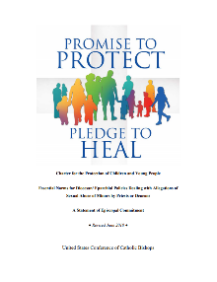  Download
September 9th  “Holy Spirit, comforter of hearts, heal your people’s wounds and transform brokenness into wholeness. Grant us the courage and wisdom, humility and grace, to act with justice. Breathe wisdom into our prayers and labors. Grant that all harmed by abuse may find peace in justice. We ask this through Christ, our Lord.”  USCCB Secretariat of Child and Youth Protection, “Promise to Protect” Bookmark. | 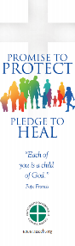  Order Download
September 16th  “Sometimes our actions speak for themselves; other times, words are needed. Whatever the situation, Jesus knows how to speak to each person's heart; we simply need to follow where he leads.”  USCCB Secretariat of Pro-Life Activities  “How to Build a Culture of Life,” www.usccb.org/culture-of-life | 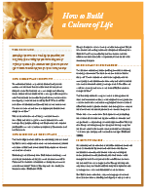  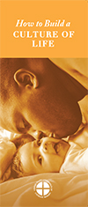  Order Download
September 23rd  “We are created to walk with and support one another; we don't need to fear reaching out in love. Help your friend experience the strength of God's message that resounds throughout time: “Do not fear: I am with you” (Isaiah 41:10).  USCCB Secretariat of Pro-Life Activities  “What to Do When a Friend Is Considering Abortion”, www.usccb.org/l-o-v-e  NABRE © 2010 CCD. Used with permission. | Order Download
September 30th  “The dying process is a sacred time—a final season to seek closure in this life and prepare for the next in the hope of sharing in Christ's Resurrection. As you enter into this season with your friend or family member, ask God to accompany both of you.”  USCCB Secretariat of Pro-Life Activities  “Caring for Loved Ones at Life’s End,” www.usccb.org/endoflifecare | 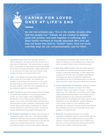  Order Download

Word of Life - September 2018

Bulletin Art
You are welcome to use these and other downloadable images from the online Respect Life image gallery, provided they are not altered in any way, other than the size. Thank you!

Sunday, September 2nd, 2018
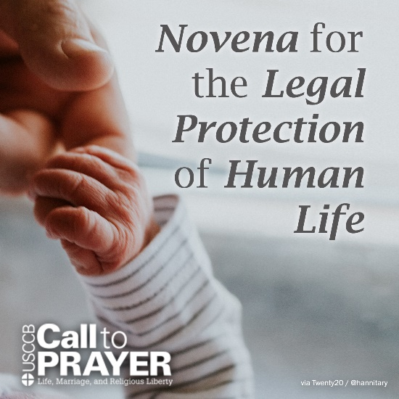
- Download Image

Sunday, September 23rd, 2018
- Do You Know Roe? (Download)
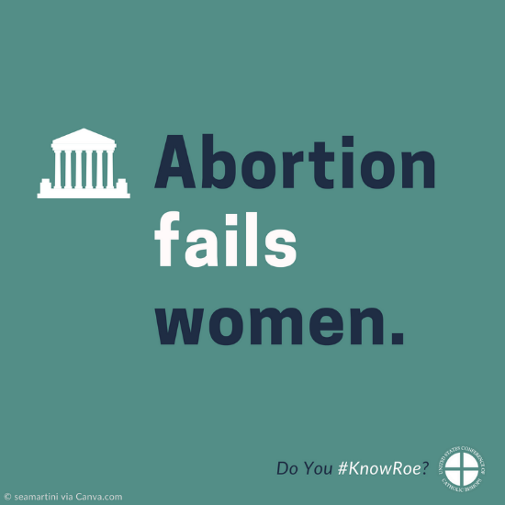
- Download Image

