Word of Life: October 2018
Recommended dates are provided, but you are welcome to use these materials at any time!
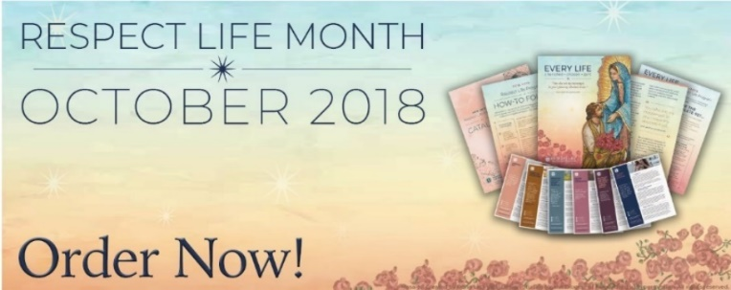
Respect Life Month
The 2018-19 Respect Life Program resources have been developed to assist you in helping Catholics understand, value, and become engaged with building a culture that cherishes every human life.
A variety of materials are available to order in print or to download online!

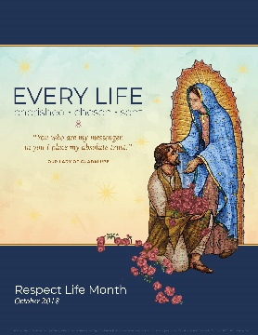
Featured Resources
- Respect Life Month Toolkit (images, bulletin inserts & more)
- Respect Life Clergy Kit (action ideas, links to Respect Life Month toolkit & other resources)
- Homily Helps
- Bulletin Cover / Bulletin Wrapper

Sample Pulpit Announcements

(2018-19 Respect Life Reflection: Order / Download)

Option 1: Respect Life Sunday (October 7)

This weekend, Catholics nationwide celebrate Respect Life Sunday with the theme "Every Life: Cherished, Chosen, Sent." See this week's bulletin for a short reflection.

Option 2: Respect Life Month

This October, Catholics nationwide celebrate Respect Life Month with the theme "Every Life: Cherished, Chosen, Sent." See this week's bulletin for a short reflection.

Sample Bulletin Announcement
Celebrate Respect Life Month!
You're invited to join Catholics nationwide in celebrating Respect Life Month this October with the message "Every Life: Cherished, Chosen, Sent"! Learn more at www.usccb.org/respectlife.

Word of Life – October 2018
Intercessions for Life
October 7th  May we show by our words and actions  that every human life  is cherished and chosen by God;  We pray to the Lord: | Twenty-seventh Sunday  in Ordinary Time  (Observed in U.S. as Respect Life Sunday)
October 14th  For all of us, who are called by name  to be disciples of Christ:  May he give us courage to open our hearts  to those who are most vulnerable  during this Respect Life Month and always;  We pray to the Lord: | Twenty-eighth Sunday  in Ordinary Time
October 21st  May we build a culture of life  by embracing our mission  as messengers of God’s love;  We pray to the Lord: | Twenty-ninth Sunday  in Ordinary Time
October 28th  For the U.S. Catholic bishops:  May the Lord grant them strength  to be holy shepherds in protecting  and leading their sheep;  We pray to the Lord: | Thirtieth Sunday  in Ordinary Time

Word of Life – October 2018

Bulletin Quotes

October 7th  “By embracing the mission entrusted to him, St. Juan Diego helped bring Christ’s transforming love to cultures gripped by oppression and death. . . . Like St. Juan Diego, let us embrace our daily mission to help others encounter God’s transforming, life-giving love.”  USCCB Secretariat of Pro-Life Activities  2018-19 Respect Life Reflection | 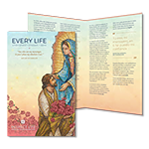  Order | Download
October 14th  “Heavenly Father…  give us love for all people,  especially the most vulnerable,  and help us bear witness to the  truth that every life is worth living.”  USCCB Secretariat of Pro-Life Activities,  “Every Life is Worth Living” Prayer Card | 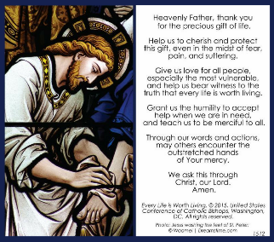  Order | Download
October 21st  “Pray daily for the end to abortion, that all mothers and children experience the loving support of the Church community, and that all who suffer after abortion find healing and peace.”  USCCB Secretariat of Pro-Life Activities,  “Another Look at Abortion” | 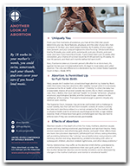  Order | Download
October 28th  “To the survivors of abuse and the families who have lost a loved one to abuse, I am sorry. You are no longer alone.” – Cardinal Daniel N. DiNardo of Galveston-Houston, President of the USCCB  “President of U.S. Conference of Catholic Bishops Renews Commitment for Greater Effectiveness and Transparency in Disciplining Bishops,” August 27, 2018  http://bit.ly/2NkMNzd | 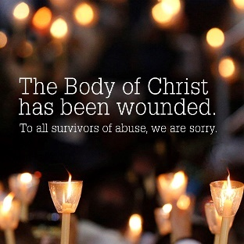

Word of Life – October 2018

Bulletin Art
You are welcome to use these and other downloadable images from the online Respect Life image gallery, provided they are not altered in any way, other than the size. Thank you!

Sunday, October 7th, 2018
Featuring Reflection: “Every Life: Cherished, Chosen, Sent”
- Bulletin Insert: A variety of formats are available online!
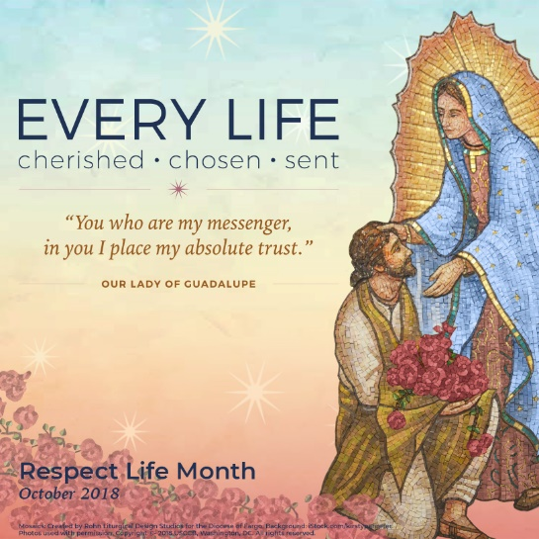
- Download Image: English | Spanish

Sunday, October 28th, 2018
Featuring “Every Life is Worth Living” Prayer
- Prayer Card: Order | Download | Text-Only
- Download Image: English | Spanish
