Word of Life: February 2020
Recommended dates are provided, but you are welcome to use these materials at any time!
Featured this Month…
February 7–14, 2020: National Marriage Week
Sunday, February 9, 2020: World Marriage Day
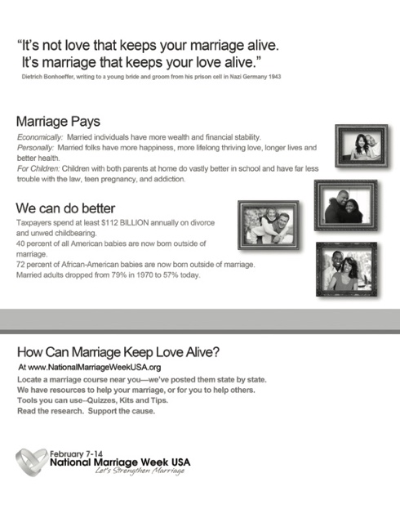
The upcoming observances of National Marriage Week (February 7-14, 2020) and World Marriage Day (Sunday, February 9, 2020) are opportunities to focus on building a culture of life and love by supporting and promoting marriage and the family. The USCCB Secretariat of Laity, Marriage, Family Life and Youth offers many resources to assist you in your efforts. The theme for 2020 is “Stories from the Domestic Church.”
- Flyer
- Prayer for Married Couples

Resources for the celebration of National Marriage Week will continue to be added to the USCCB website. Other resources can be found at www.foryourmarriage.org/celebrate-national-marriage-week.

Related Pro-Life Resources
Seven Considerations while Navigating Infertility
Married Love and the Gift of Life
Healing within Marriage from an Abortion

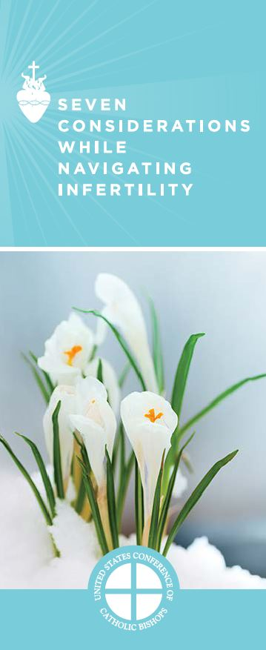

Word of Life – February 2020
Intercessions for Life
February 2nd  May all expectant parents  joyfully welcome their children as gifts from God,  as Mary and Joseph welcomed the Christ Child;  We pray to the Lord: | Feast of the Presentation of the Lord
February 9th  For the grace this week  to see Christ in each person we meet  and extend the Lord’s mercy and compassion;  We pray to the Lord: | Fifth Sunday in Ordinary Time
February 16th  For the times we have disregarded God’s commandments  and violated the sanctity of human life:  May we repent, receive the Lord’s mercy,  and live according to His laws;  We pray to the Lord: | Sixth Sunday in Ordinary Time
February 23rd  May every human person,  from conception to natural death,  be recognized as a temple of God,  in whom the Spirit dwells;  We pray to the Lord: | Seventh Sunday in Ordinary Time
February 26th  During this Lenten season,  may all who have participated in abortion  receive the courage to return to the Lord,  who is gracious and merciful;  We pray to the Lord: | Ash Wednesday

Word of Life – February 2020

Bulletin Quotes
February 2nd  “When parents say ‘yes’ to life for their child, they are saying ‘yes’ to the most loving and healing path for all involved. When God invites us to draw close to him by following his commandments (Jn 14:15), he does so because he wants what is best for us. By saying ‘yes’ to life for their child, which is morally good and right, parents are placing their trust in God and embracing their child and the life their child has been given for as long as it is given.”  USCCB Secretariat of Pro-Life Activities  “Supporting Families Who Receive a Prenatal Diagnosis” | 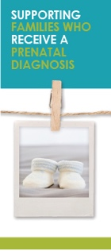  Order | Download
February 9th  “As disciples of Jesus, we are called to become neighbors to everyone (cf. Lk 10:29-37), and to show special favor to those who are poorest, most alone and most in need. In helping the hungry, the thirsty, the foreigner, the naked, the sick, the imprisoned—as well as the child in the womb and the old person who is suffering or near death—we have the opportunity to serve Jesus.”  Pope Saint John Paul II, Evangelium vitae, 87.  © 1995 Libreria Editrice Vaticana. Used with permission. | 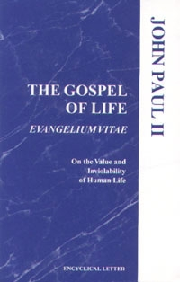  Order | Read Online
February 16th  “Prayer is the foundation of all that we do in defense of human life. Our efforts—whether educational, pastoral, or legislative—will be less than fully fruitful if we do not change hearts and if we do not ourselves overcome our own spiritual blindness. Only with prayer—prayer that storms the heavens for justice and mercy, prayer that cleanses our hearts and our souls—will the culture of death that surrounds us today be replaced with a culture of life.”  “Pastoral Plan for Pro-Life Activities”  United States Conference of Catholic Bishops | 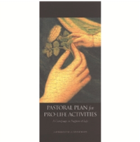  Order | Read Online
February 23rd  “The essence of our identity is that we are created in God's image and likeness and loved by Him. Nothing can diminish the priceless worth of any human life. Every person is cherished.”  USCCB Secretariat of Pro-Life Activities  2018-19 Respect Life Reflection | 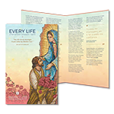  Order | Download

Word of Life – February 2020

Bulletin Art
You are welcome to use these and other downloadable images from the online Respect Life image gallery, provided they are not altered in any way, other than the size. Thank you!
Sunday, February 2, 2020
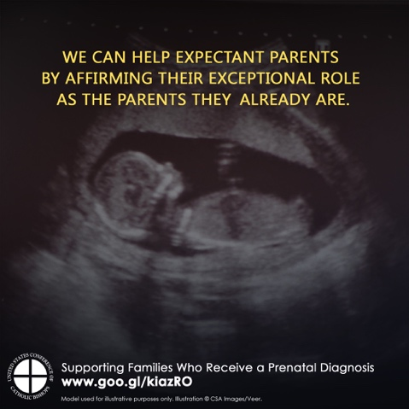
Download: English | Spanish

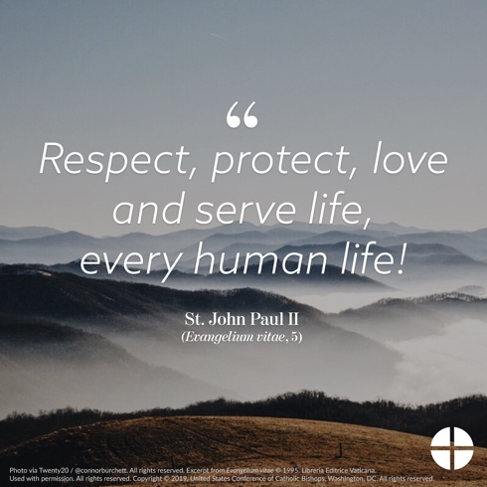
Sunday, February 9, 2020

Download: English | Spanish

Sunday, February 23, 2020
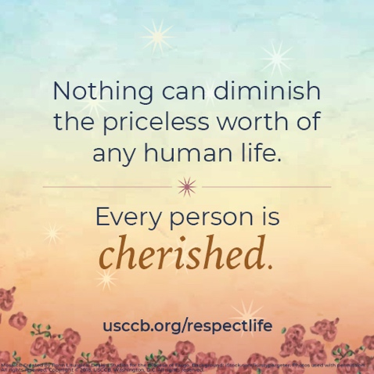
- Download: English | Spanish

